WORSHIP IN GIVING (TITHES & OFFERINGS)

Today’s Offering:
“Church Budget”
- Cash
- Bank Machine (table by the door)
- Online banking -
etransfer@victoriaadventist.ca.
- AdventistGiving.org

October – Birthdays:

Jun A., EnChin L., Joy A., Pastor Marian K., Alipo N., Jose C., Tyler O., Andrii B., Daniela P., Elvina H., Pam W.

Today’s Worship Team:
Elder on Call: Elder Domingo Daniels
Deaconesses: Lymibeth V. & Pam W.
Deacons: Hugo M. & Amgad Z.
SS Teachers: Domingo D. Alipo N. Agnes O
Greeters: Percy & Addlight R.
Praise: Michael M. & Friends
Children's Story: Tariro Murwira

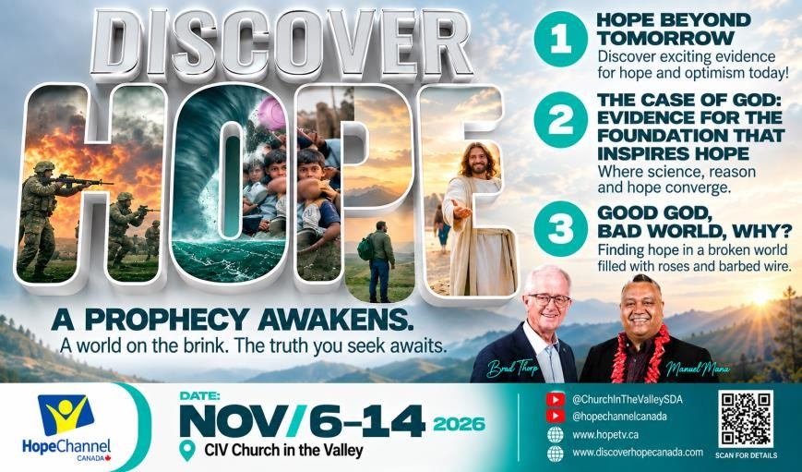
.

Oct 24 @ 6pm – TALENT NIGHT!
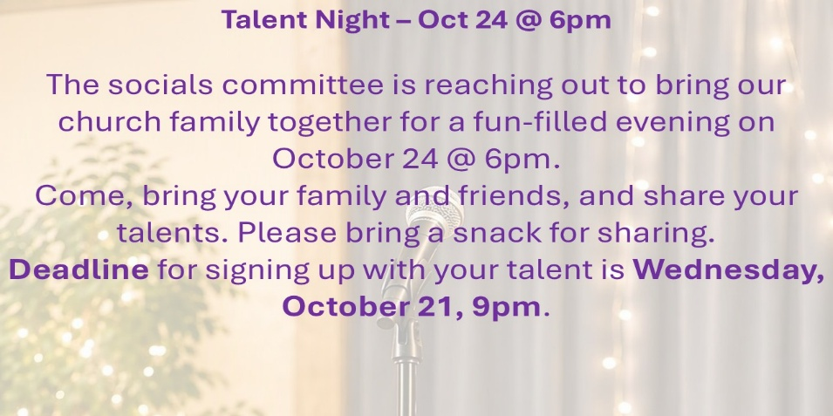

Nov 6-8, Youth Leadership Summit
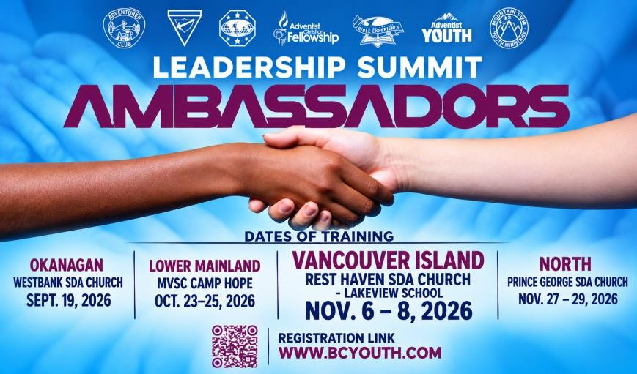

COUPLES CRUISE 2027 - Two Hearts, One Unforgettable Journey. Set sail together on an unforgettable Alaska Hubbard Glacier Cruise, taking place May 30–June 6, 2027. Enjoy breathtaking scenery, meaningful time together, and the spectacular beauty of Alaska while creating special memories with the one you love. Joining us on this special journey will be Mike and René Lemon, hosts of It Is Written Canada. For pricing and additional information, please see the poster. We hope you’ll join us for this unforgettable journey together! Thank you for your continued help in sharing Conference news, events, and ministry opportunities with your church families. Your assistance is greatly appreciated!

Victoria Seventh-day Adventist Church 729 Cordova Bay Road, Victoria, BC Sabbath, October 17th, 2026
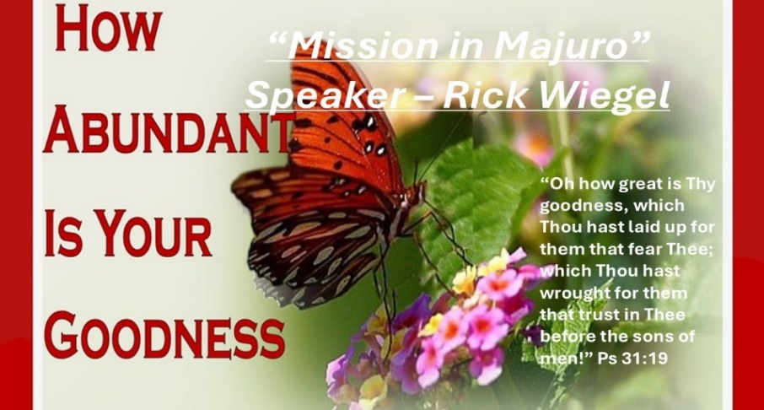

JOIN US at LCS for LIVE Worship Service. We want our worship to be a blessing to all people. Please ALSO visit our LIVE YOUTUBE Channel.

While at YouTube search for “Church In Victoria”.
Our Vision: “Restoring God’s Image in our Community: Restore, Redeem, & Regenerate.”
Our Mission: “Restore God’s Image and His Love in Humanity through Worship, Education, Community Services, Fellowship, & Health.”
Our Core Values: Adventist Education, Authentic Worship, Service & Ministry, Strength in Diversity, Happy Healthy Living.
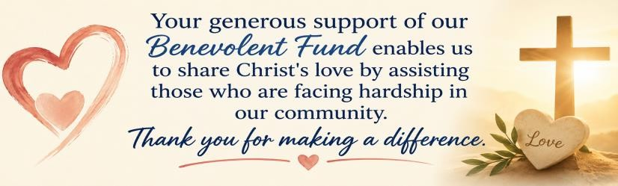
Tonight’s Sundown: 6:21pm

Sabbath, Oct 17, 2026
10:00am - Sabbath School (Bible Study)
11:00am –Worship Service
Opening Song Congregational Singing
“Thankyou Lord” (Don Moen)
Opening Prayer & Welcome Elder Domingo Daniels
Worship in Giving Local Church Budget
Children’s Story Tariro Murwira
Worship in Praise Michael M. & Friends
Intercessory Prayer David Conceicao
Special Music Kedesha Brown
Today’s Speaker Rick Wiegel
"Mission in Majuro”
Inspirational Song (Video) Steve Green
“I Will Go”
Closing Song Congregational Singing
“Hark the Voice of Jesus Calling”
Closing Prayer Rick Wiegel
Preaching Schedule
Oct 24 | Agnes Oosterhof | Community Services Sabbath
Oct 31 | Pathfinder & Adventurer Induction
Nov 7 | Pastor Kossovan | God’s 7 Spirits Before the Throne
Nov 14 | Domingo Daniels | International Sabbath

Oct 17th - EVENTS & ANNOUNCEMENTS
Sab – 10am | Sabbath School / Bible Study in Small Groups
Sab – 11am | Rick Wiegel – Mission Trip Testimony
Sab – 12:30pm | Fellowship Meal! Everyone Welcome!
Sab – 2:00pm | Adventurers
Sun, Oct 18@2-4pm | Pathfinders’ Car Wash @ LCS (#1)
Sun, Oct 18@4-6pm | Men’s Ministries Bowling @ Uptown (#2)
Wed, Oct 21@8pm | ZOOM Prayer Meeting – Pastor Lucian Poama  https://us02web.zoom.us/j/8727921729 (back page) (3)
Oct 24 | Community Services Guest Day (#4)
Oct 24 @6pm | Talent Night @ LCS (Back Page)
Oct 31 @ 5-8pm | Light Up the Night @ LCS (Children’s Event)
Nov 6-8 | Leadership Summit for Youth Leaders (Back Page)
Nov 6-14 | Discover Hope Live @ discoverhopecanada.com (back page)
Nov 14 Time (TBA) | Board Game Night
Happy Sabbath! We are delighted that you have chosen to worship with us today. May today’s worship inspire, encourage, & draw us closer to our Saviour. You are invited to a fellowship meal after worship!
1. Sun, Oct 18 @ 2-4pm Pathfinder Car Wash
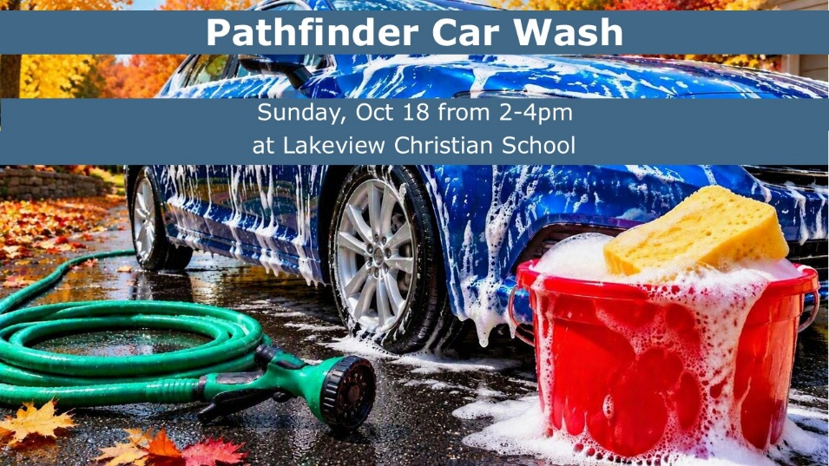
2. Sun, Oct 18– Men’s Ministries Bowling

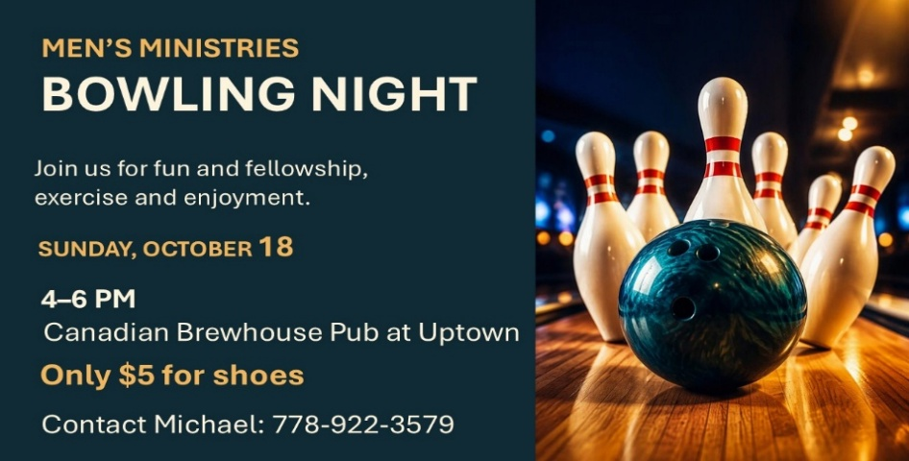
3. Wed, Oct 21 @ 8pm Prayer Time
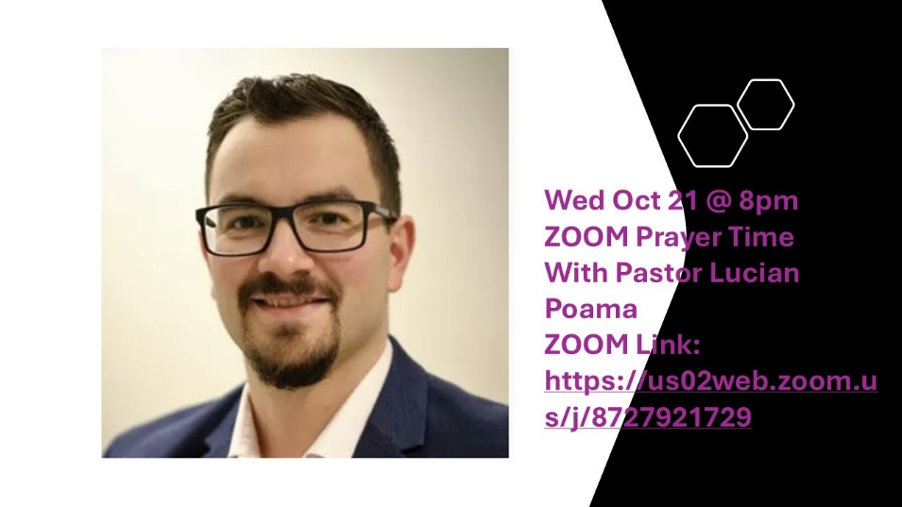servi
4. Sab, Oct 24 – Community Services Day

