WORSHIP SERVICE
We pray you will gain a blessing today!

April 4th, 2026

Prelude Sandee Bales
Welcome & Announcements Rita Tasche
Opening Praise* Praise Team
#166 Christ, the Lord is risen today
Invocation Pr. Dean Coridan
Call for Tithes & Offerings Rita Tasche
Combined Youth Ministries
Mission Video "The Email She Almost Missed"
Scripture Ephesians 2:8-10 Lillian Kelly
Special Music Bette Patterson
Baby Dedication Baby Steven Nelson
Parents: Denver & Isabella Nelson
Speaking: Pastor Sixto Ramos
Children’s Story Eduard Boshtan
Praise Service Praise Team
Prayer+ Rick Stout
Message Pr. Dean Coridan
Closing Song “Were You There” Caleb Rittenour
Postlude Sandee Bales
*Congregation Please Stand +Congregation Please Kneel
Elder in Charge: Gary Patterson
Deacon in Charge: Caleb Rittenour
Chorister: Caleb Rittenour
CHURCH DIRECTORY
Pastor – Dean Coridan 515-419-2709
Head Elder – Curt Kelly 573-881-4632
Head Counselor – Arlene Saville 573-682-2389
Head Deacon – JC Roney 573-982-9072
Head Deaconess – Tina Burkett 573-881-6888
Treasurer – Brad Foster 573-819-0503
Clerk – Cheryl Patterson 573-982-9119
garncher608@gmail.com
Bulletin churchbulletin@sunnydale.org
Please send bulletin info by 8pm Wednesday night
Church Directory members.instantchurchdirectory.com
contact Kristen K. at 320-267-1146
Sunnydale Adventist Elementary 573-682-2811
Sunnydale Adventist Academy 573-682-2164
Community Service Center 573-682-1322
M 9-2 pm, Th 6-8 pm
Sunnydale Radio Stations:
88.7 FM KSDQ 94.9 FM KSDC
(3ABN radio affiliate) (Radio 74 International affiliate)
Low power station
Live Stream – Russell Dick 573-228-0297

Upcoming Events

Tuesdays: Family Night, 7pm
Wednesdays: Converge, 6:30pm

Donald Weber 573-239-0512573-982-936
Monthly Church Meetings:
Elementary School Board Mtg |  | 2nd Monday @ 7 pm
Church Board Mtg |  | 3rd Monday @ 7 pm
Community Service Board Mtg
 | 1st month of Quarter – 4th Mon @ 7 pm
Church Potluck | 2nd Sabbath of each month
Sunset tonight: | 7:35 pm
Sunset next week: | 7:42 pm
Offering next week: | Hope Channel



Welcome
Happy Sabbath
Sunnydale SDA Church
6964 Audrain Rd. 9137
Centralia, MO 65240
Ph: 573-682-5313
www.sunnydalemo.adventistchurch.org
SABBATH SCHOOL CLASSES
Prayer time in Sanctuary 9:20 – 9:40 AM
Sabbath School Classrooms and Teachers
Sanctuary: E. Bales/J. Stone/J.Davis
“Uniting Heaven and Earth”
Conference Room: C. Kelly/P. Kelly
“Desire of Ages”
Lower Level: M. Olson/S. Bales/C. Hubble
“Uniting Heaven and Earth”
Lower Level: T. Burkett
“Uniting Heaven and Earth”
LL Young Adults: K. Barker/J. Schnell
“Uniting Heaven and Earth”
LL Youth (HS age) C. Nedrow/K. Barker
“The Ultimate Power”
LL Junior (10-14 years) G. Stone/R. Everhart/K. Mathis
“God’s Grace Is a Gift”
Children’s Classes Main Level
Primary (6 – 9 years) R. McMillen
Kindergarten (4 – 1st grade) A. Saville/
F. Eckley/G. Coridan
Cradle Roll (0 – 3 years) M. Prowant/
K. Kuehmichel/T. McMillen
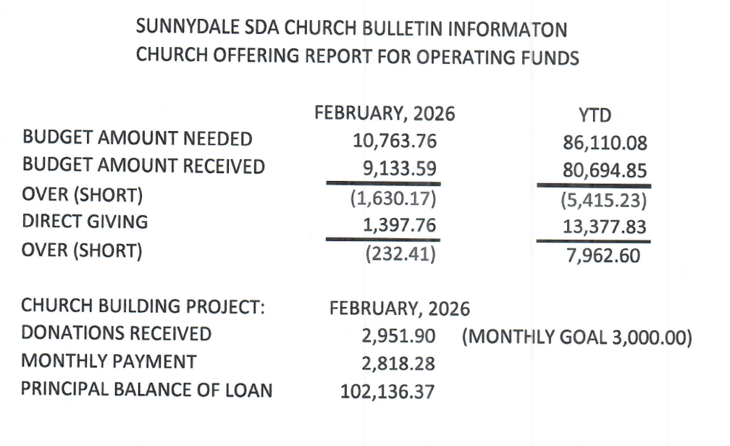

ANNOUNCEMENTS

2nd Reading Membership Transfer
Derrell/Virginia Everhart, Arianna, Lyton, Ryton, Karyana from New Iberia SDA Church, New Iberia, Louisiana to Sunnydale SDA Church, Centralia, Missouri

Pathfinders
Congratulations to our Sunnydale Flyers PBE team! They, along with their Sedalia teammates, earned a 1st place finish at the Union level in Colorado and are now headed to the Division PBE in Hawthorne, FL, on April 18th.
The team is incredibly grateful for your prayers and support thus far. If you would like to help sponsor their upcoming trip to Florida, please contact Michelle Prowant at 573-982-9407. Thank you for investing in our pathfinders!

Man Camp
Man Camp (15 up) and Young Mans Camp (10-14) at Camp Heritage is April 24-26 bring RV or stay in cabins see details on IA-MO conf. Website or contact Micky at 573-819-6040

Baby Shower
All are invited to James and Sophia March's baby shower, Sunday, April 12, 2026 @ 2 pm., here at Sunnydale in the multipurpose room. They are having a boy. She is asking for books instead of cards. They are registered at Amazon. Thank you! If you have any questions, please call Mandy March 573-982-9790. Thank you, Jodi Schnell, for all your help!

Church Directory
If you are interested in a printed copy of the Church Directory, please contact Kristen Kuehmichel at 320-267-1146

Community Service Center Food Pantry
SDA Community Services Food Pantry, located at 320 W. Hwy 22 Centralia is open every second and third Monday of the month from 9:00am until 2:00pm for those in need of assistance. Please contact Jim (573) 228-0078 or Sherrie Fisk (573) 355-0371 or Glenda Stone (573) 999-9356 for further information.

Family Night
Tuesdays at 7-8:30pm in the multipurpose room for volleyball, basketball, soccer, dodgeball, ping pong or bring table games.

Converge
Converge series "Biblical Prescriptions for Life" is a 7-part series by Dr. James Markum, Wednesdays with supper at 6pm and study sessions at 6:30-7:30

Prayer Quilts
There is a high demand for prayer quilts and more volunteers are needed to help keep up. Meet at Crossroads in Centralia every Thursday from 10AM-3PM. If you can’t stay the whole time, even an hour or two would be a big help and greatly appreciated. Contact Rita Tasche for more details

Prayer is powerful!
The following people have requested that you
pray for them:
Mark McMillen (Cancer)
Vince (Rita Tasche’s son, brain mass)
Terry Plank recovery from surgery
Mary Lou Plank - heart issues
Pr. Dean & Gail
SAA & SAE Students
SAA Mission Trips (Students & Staff)

