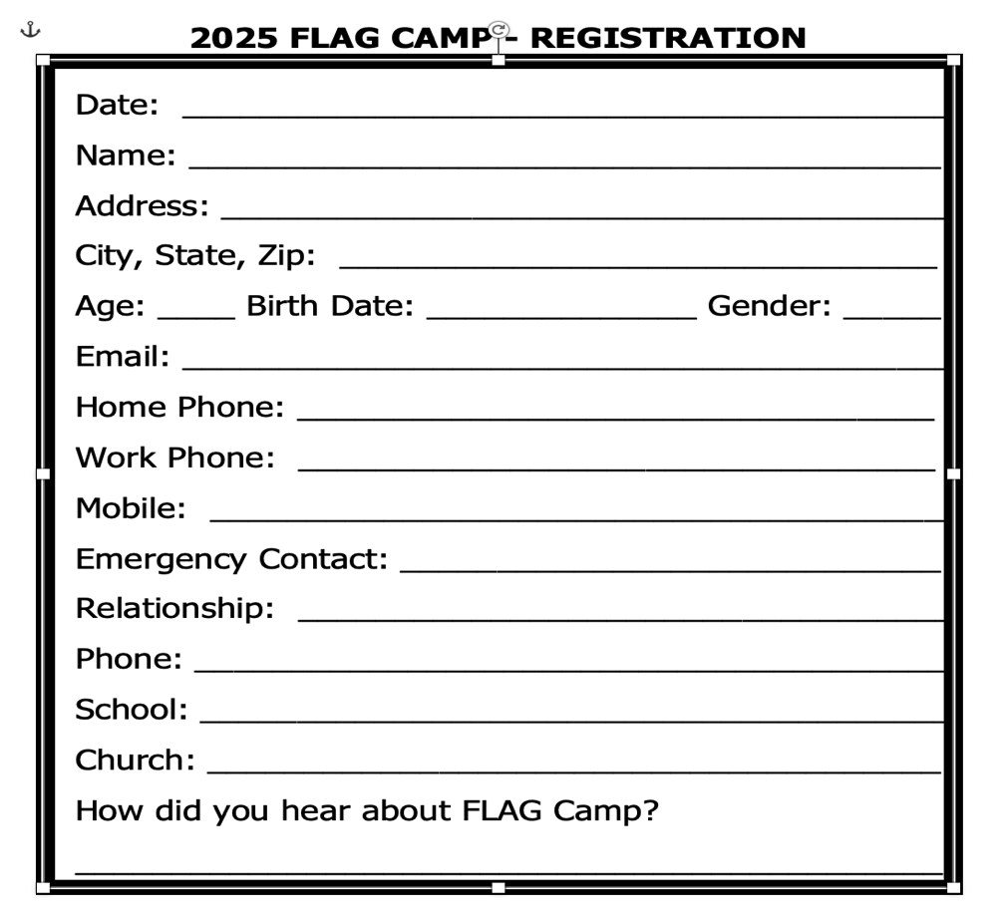

Date:
June 22 – 26, 2025, Monday thru Friday

Time:
8:00 AM – 5:00 PM

Activities:
Bible Stories, Crafts, Games, Music,
Nature Lessons, and Swimming

Location:
Park shelter at
3161 Greenbriar Rd, Draper, VA 24324

Cost:
Includes all crafts and swimming fees. Registration Fee: $80 for the Week, or $16/day

Early Registration: $70 for the Week
Required by June 15, 2025

Ages:
6 to 12 years of age

Daily Schedule:
7:30 Pre Care
8:00 Meet ‘n Greet
8:15 Line Call
8:30 Activities for all Ages
12:00 – 12:40 Lunch
12:40 Unit Time
1:40 Swimming
4:00 Clean-Up
4:30 Dismissal for the Day
5:30 Post Care Ends

NOTE TO CAMPERS
A snack with juice and water will be provided.
Bring the following items daily:
- Bring a bag lunch or free lunch provided
- Swim Suit, Towel, Sunscreen, Etc.

FLAG Camp Cookout – Randolph Park, Pavilion
Friday, June 27, 2025; 5:30 p.m.

Register Early by June 15th for Discount -
Mail form and fees to:
FLAG CAMP
C/O 4326 RUSSELL RD., PULASKI, VA 24301
Telephone: (540) 440-0539
Email: djenkins5878@gmailcom

Shirt Size: (Circle one)
Youth Small Medium Large X-Large
Adult Small Medium Large X-Large
Medical Information and Release:
History (current illness, chronic conditions): _____________________________________________
_____________________________________________
_____________________________________________
Allergies: _____________________________________
_____________________________________________
Medications: __________________________________
Physician: ____________________________________
Phone: ______________________________________
Insurance: ___________________________________
Policy #: ____________________________________
Please initial the consents you are authorizing, then sign and date this form at the bottom. Those marked with an asterisk must be consented to for child to be a FLAG camp camper.

___ *The child named above has my consent to participate in swimming.
___ I give consent for pictures of my child to be used for future advertising purposes.
___ *In the event of an accident or urgent illness, I give
permission to the FLAG Camp staff to authorize necessary emergency treatment for this child.
___ *I give permission to FLAG camp staff to bus my child to and from the waterpark at Randolph Park, Dublin VA.

Signature _____________________________________

Relationship _______________ Date _______________

