PLEASANT STREET SDA CHURCH
A Welcoming Place for All, Fostering Discipleship
SABBATH SCHOOL
November 7, 2026
🙤 Bible Study 🙤 Fellowship 🙤 Outreach 🙤 World Mission 🙤
🙤 Praise and Worship 🙤 Praise Team

🙤 Opening Song 🙤 Hymn #268
“Holy Spirit, Light Divine”

🙤 Opening Prayer 🙤 Carmen Vanhorne

🙤 Scripture Reading 🙤 Congregation
"For whatever things were written before were written for our learning, that we through the patience and comfort of the Scriptures might have hope" ---Romans 15:4, NKJV.

🙤 Welcome 🙤 Superintendent

🙤 Church at Study 🙤

The Prophetic Writings

🙤 Mission Emphasis 🙤 Restless Hearts

🙤 Closing Remarks 🙤
"As we close our study on 'The Prophetic Writings,' let’s carry the promise of our memory text from Romans 15:4 with us. The things written in Scripture were given for our learning so that through patience and comfort, we might have hope. God entrusted His infinite truth to human 'earthen vessels'—using their unique voices, styles, and even literary assistants like Baruch and Tertius—to ensure His message would reach us today. Let’s leave this place trusting completely in the authority, preservation, and unchanging love found in God's written Word."

🙤 Closing Song 🙤 Hymn #279
“Only Trust Him”

🙤 Closing Prayer 🙤 Clyde Vanhorne

WORSHIP SERVICE
11:00AM

Praise and Worship Praise Team

Hymn of Adoration Hymn #88
“I Sing the Mighty Power of God”

Intercessory Prayer Paul Bastien

Greetings and Ministry Highlights Clerk

Welcome Emily Bastien

Children’s Story Video

Special Music Judith Gabriel

Worship in Giving Marcia Mason
Local Church Budget

Introduction of Speaker Mark Morana

Scripture Reading Leeson Parsells
Mark 10:17-22

Meditation Judith Gabriel

Sermon Pastor Kenroy Malcolm
The Kingdom and Riches

Hymn of Consecration Hymn #327
“I’d Rather Have Jesus”

Prayer of Consecration Mark Morana

LOOKING AHEAD

FAMILY OF THE WEEK
Today – Lockhart Family
11/14 – Martineau Family
11/21 – Mason Family
11/28 – Matale/Artey Family

SICK/SHUT-IN
Majrie Thompson
Valdine Pyatt – RegalCare at Worcester
Angel Hampton – RegalCare at Worcester
Ivy Forbes – Reservoir Healthcare, Marlborough
John Piscione – Odd Fellows Home, Worcester

TREASURY CORNER
Members are encouraged to utilize online giving as the primary means of giving. Visit the church website at https://www.pleasantstreetsda.org/ select “Give” on the top menu bar or via the Adventist Giving Website at
https://adventistgiving.org/#/org/AN4MLG/envelope/start.

Members can mail their checks to our PO Box:
Pleasant Street SDA Church
PO Box 20929
West Side Station
Worcester, MA 016

BULLETIN CORNER
Please submit bulletin information to psdabulletin@gmail.com.
All information is due by Tuesday of each week.

BABY BLESSING
Baby Blessings conducted by the Pastor are scheduled for the 3rd Sabbath of each month. Please get in touch with the church clerk for further information.

DIRECTORY
Pastor | John K. Amoah | 508-410-2414
Head Elder | Milton Wright | 508-887-6524
Church Clerk | Myrna Campbell-Claxton | 508-847-0115
Head Deacon | Paul Bastien | 301-928-3250
Head Deaconess | Winnefred Fearon | 508-752-9490

DEPARTMENT NEWS

NOVEMBER EVENTS
8th – Adventurer Club Meeting
8th – Diaper Ministry Distribution
15th – Pathfinder Club Meeting
21st – Thanksgiving Program and Dinner
22nd – Adventurer Club Meeting
29th – Pathfinder Club Meeting

NOVEMBER BIRTHDAYS
Rosemarie Young (4), Dujon Henry (7), Michael Mason (8), Darlyne Joseph (9), Karen Zeno (13), Dashawn Adonteng (13), Guiriana Meunier (17), Aliya-Marie Melville (18), Paul Vassell Jr. (19), Camille Bryant (21), Claudio Beckford (23), Craig-Michael Chambers (23), William Matale (24), Beverley Chambers (28)

Did we miss you? If your birthday was not listed and you would like it to be, please submit a note to one of the Clerks.

NOVEMBER OFFERING SCHEDULE
Today - Local Church Budget
14th - Annual Sacrifice for Global Mission
21st – Local Church Budget
28th - Local Conference Advance

MEMBERS ON DUTY
Elder – Mark Morana
Superintendent – Beverley Chambers
Deacons – David Gogo, Claude Beckford
Deaconesses – Winnifred Fearon, Erica Whyte
Ushers/Greeters – Vivienne Morana, Eby Martineau

ZOOM MEETING INFORMATION

PS-SDA Church Service
Time: Every Sabbath 9:30 AM Eastern Time (US and Canada)
Join Zoom Meeting
https://zoom.us/j/96683645613?pwd=ME5IMnpPVlM3VDZUa2Z1QkpxZ1BCdz09

Meeting ID: 966 8364 5613
Password: 970992

Phone: 1-929-205-6099

PS-SDA Prayer Meeting
Time: Every week on Wednesday at 7:00 PM Eastern Time (US and Canada)
Join Zoom Meeting
https://zoom.us/j/93236151870?pwd=c2hGL29TSUxtRDFqSkJNdzhIa0JRQT09

Meeting ID: 932 3615 1870
Password: 234741

Phone: 1-929-205-6099

Child Safety is of the utmost importance in our Church community. The Southern New England Conference participates in Shield the Vulnerable, a program that focuses on reducing potential dangers to children.
- Background checks are conducted for each person working with our children including Sabbath School, Adventurers and Pathfinders.
- Children are to be escorted by their guardian.
- Two adults are needed in each Sabbath School class (except Beginners where parents are present).

Sunset Today – 4:34pm Sunset on Friday 4:27pm

PERSONAL MINISTRY

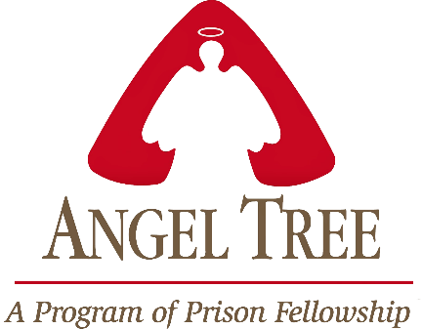

Pleasant Street Seventh Day Adventist Church

Prison Ministry Department

Invites you to Participate in the

Angel Tree Program
Unwrap the Joy

When Mom, Dad or Family Member goes to prison, a child may feel lonely and forgotten. Especially around the holidays. Share the hope of Jesus with a hurting child in your community as you deliver a Holiday gift and a personal message of love on behalf of their parent or family member in prison.

It starts with a gift and leads to restored lives.

*** MORE INFORMATION COMING SOON***

HEALTH MINISTRY
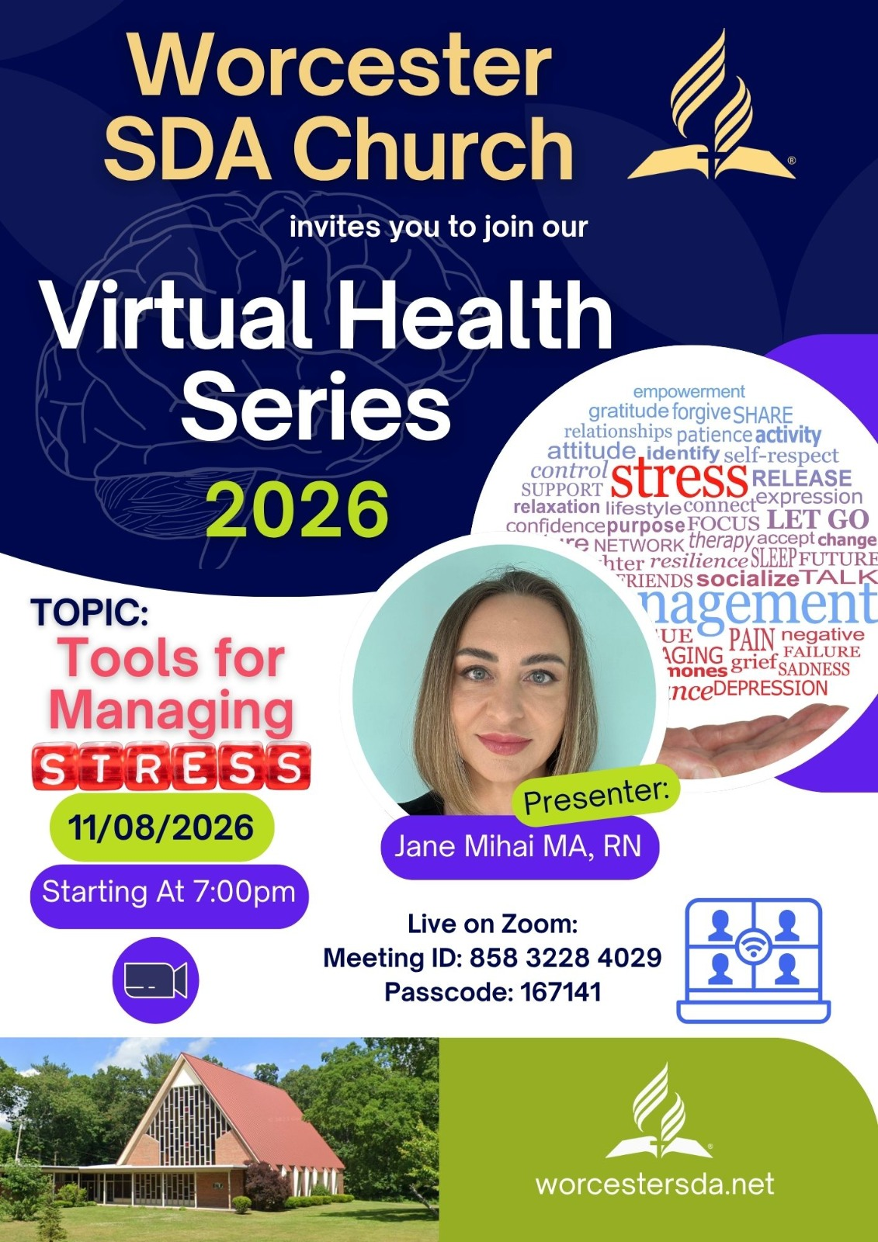

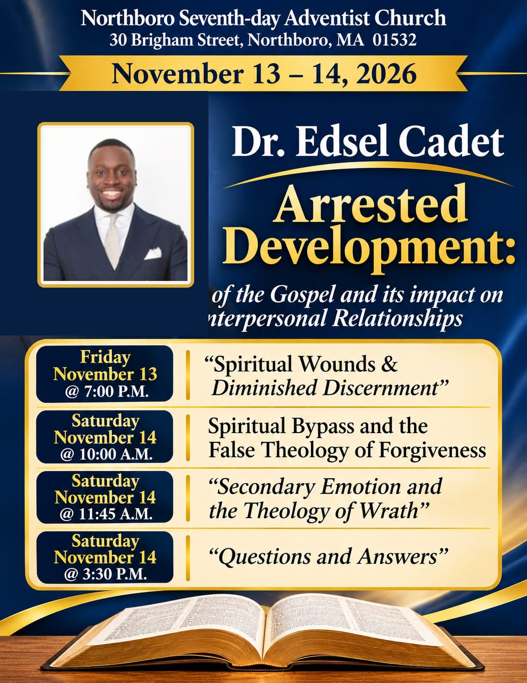

SOUTHERN NEW ENGLAND CONFERENCE






