PLEASANT STREET SDA CHURCH
A Welcoming Place for All, Fostering Discipleship
SABBATH SCHOOL
OCTOBER 31, 2026
🙤 Bible Study 🙤 Fellowship 🙤 Outreach 🙤 World Mission 🙤
🙤 Praise and Worship 🙤 Praise Team

🙤 Opening Song 🙤 Hymn #499
“What a Friend We Have in Jesus”

🙤 Opening Prayer 🙤 Superintendent

🙤 Welcome 🙤 Superintendent

🙤 Scripture Reading 🙤 Congregation
2 Peter 1:18-21, KJV

🙤 Church at Study 🙤

Revelation and Inspiration

🙤 Mission Emphasis 🙤 Video
Show Me the Truth

🙤 Question to Ponder 🙤
- What assurance do we have that the oral messages delivered by God's prophets were as inspired and reliable as the written ones?

🙤 Closing Remarks 🙤
Ellen G. White always considered the Bible as the authoritative and infallible revelation of God. The Bible reveals God's truth and His plan of salvation for the fallen human race. In that process, as we are learning, He uses prophets to communicate His messages.
—Selected Messages, book 1, p. 21.

🙤 Closing Song 🙤 Hymn #569
“Pass Me Not, O Gentle Savior”

🙤 Closing Prayer 🙤 Volunteer
BREAST CANCER AWARENESS SABBATH
WORSHIP SERVICE
11:00AM

Praise and Worship Praise Team

Hymn of Adoration Hymn #100
“Great Is Thy Faithfulness”

Intercessory Prayer Comfort Matale

Greetings and Ministry Highlights Clerk

Welcome Vivienne Morana

Children’s Story Odella Hilken

Special Music Nicole Francis

Worship in Giving Karen Zeno
Adventist Community Services

Introduction of Speaker Karen Zeno

Scripture Reading Ishea Allen
1 Kings 22:14

Meditation Nicole Francis

Sermon Morah Raina
When Faithfulness Has a Price

Hymn of Consecration Hymn #322
“Nothing Between”

Prayer of Consecration Morah Raina

LOOKING AHEAD

FAMILY OF THE WEEK
Today – Debra Lalloo
11/7 – Lockhart Family
11/14 – Martineau Family
11/21 – Mason Family
11/28 – Comfort and Goddard Matale

SICK/SHUT-IN
Majrie Thompson
Valdine Pyatt – RegalCare at Worcester
Angel Hampton – RegalCare at Worcester
Ivy Forbes – Reservoir Healthcare, Marlborough
John Piscione – Odd Fellows Home, Worcester

TREASURY CORNER
Members are encouraged to utilize online giving as the primary means of giving. Visit the church website at https://www.pleasantstreetsda.org/ select “Give” on the top menu bar or via the Adventist Giving Website at
https://adventistgiving.org/#/org/AN4MLG/envelope/start.

Members can mail their checks to our PO Box:
Pleasant Street SDA Church
PO Box 20929
West Side Station
Worcester, MA 016

BULLETIN CORNER
Please submit bulletin information to psdabulletin@gmail.com.
All information is due by Tuesday of each week.

BABY BLESSING
Baby Blessings conducted by the Pastor are scheduled for the 3rd Sabbath of each month. Please get in touch with the church clerk for further information.

DIRECTORY
Pastor | John K. Amoah | 508-410-2414
Head Elder | Milton Wright | 508-887-6524
Church Clerk | Myrna Campbell-Claxton | 508-847-0115
Head Deacon | Paul Bastien | 301-928-3250
Head Deaconess | Winnefred Fearon | 508-752-9490
DEPARTMENT NEWS

OCTOBER EVENT
Today – Breast Cancer Presentation @ 3pm

NOVEMBER EVENTS
1st – Pathfinder Club Meeting
8th – Adventurer Club Meeting
8th – Diaper Ministry Distribution
8th – Church Board Meeting
15th – Pathfinder Club Meeting
21st – Thanksgiving Program and Dinner
22nd – Adventurer Club Meeting
29th – Pathfinder Club Meeting

OCTOBER BIRTHDAYS
Yvonne Jenkins (1), Esther NgaNga (1), Jason Johnson (4), Caleb Ogunjobi (9), Valdine Pyatt (18), Patrick Chambers (24), Nathan Danville (26), Angel Hampton (29), Milton Wright (30)

Did we miss you? If your birthday was not listed and you would like it to be, please submit a note to one of the Clerks.

OCTOBER OFFERING SCHEDULE
Today – Adventist Community Services (Atlantic Union Conference)

MEMBERS ON DUTY
Elder – Karen Zeno
Superintendent – Kristina Vassell
Deacons – Paul Bastien, Clyde Vanhorne, Paul Smith
Deaconesses – Brenda Mwansa-Kamombo, Madrina Smith
Ushers/Greeters – Micah Clermeus, Goddard Matale

ZOOM MEETING INFORMATION

PS-SDA Church Service
Time: Every Sabbath 9:30 AM Eastern Time (US and Canada)
Join Zoom Meeting
https://zoom.us/j/96683645613?pwd=ME5IMnpPVlM3VDZUa2Z1QkpxZ1BCdz09

Meeting ID: 966 8364 5613
Password: 970992

Phone: 1-929-205-6099

PS-SDA Prayer Meeting
Time: Every week on Wednesday at 7:00 PM Eastern Time (US and Canada)
Join Zoom Meeting
https://zoom.us/j/93236151870?pwd=c2hGL29TSUxtRDFqSkJNdzhIa0JRQT09

Meeting ID: 932 3615 1870
Password: 234741

Phone: 1-929-205-6099

Child Safety is of the utmost importance in our Church community. The Southern New England Conference participates in Shield the Vulnerable, a program that focuses on reducing potential dangers to children.
- Background checks are conducted for each person working with our children including Sabbath School, Adventurers and Pathfinders.
- Children are to be escorted by their guardian.
- Two adults are needed in each Sabbath School class (except Beginners where parents are present).

Sunset Today – 5:42pm Sunset on Friday 4:34pm

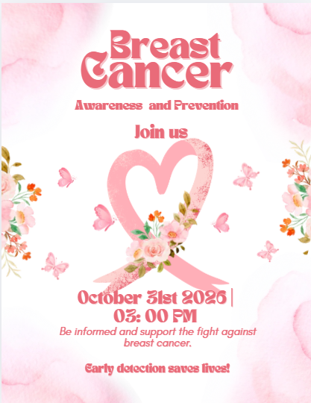
Wear Pink for Breast Cancer Awareness Sabbath!
On Sabbath, October 31, we invite our entire Pleasant Street church family—men, women, youth, and children—to wear pink as we unite in raising breast cancer awareness, honoring survivors, remembering loved ones, and supporting those affected. Together, let's spread hope, encourage early detection, and demonstrate Christ's love and compassion. Wear pink and stand together in faith, hope, and healing!
PERSONAL MINISTRY

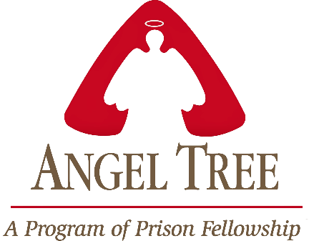

Pleasant Street Seventh Day Adventist Church

Prison Ministry Department

Invites you to Participate in the

Angel Tree Program
Unwrap the Joy

When Mom, Dad or Family Member goes to prison, a child may feel lonely and forgotten. Especially around the holidays. Share the hope of Jesus with a hurting child in your community as you deliver a Holiday gift and a personal message of love on behalf of their parent or family member in prison.

It starts with a gift and leads to restored lives.

*** MORE INFORMATION COMING SOON***

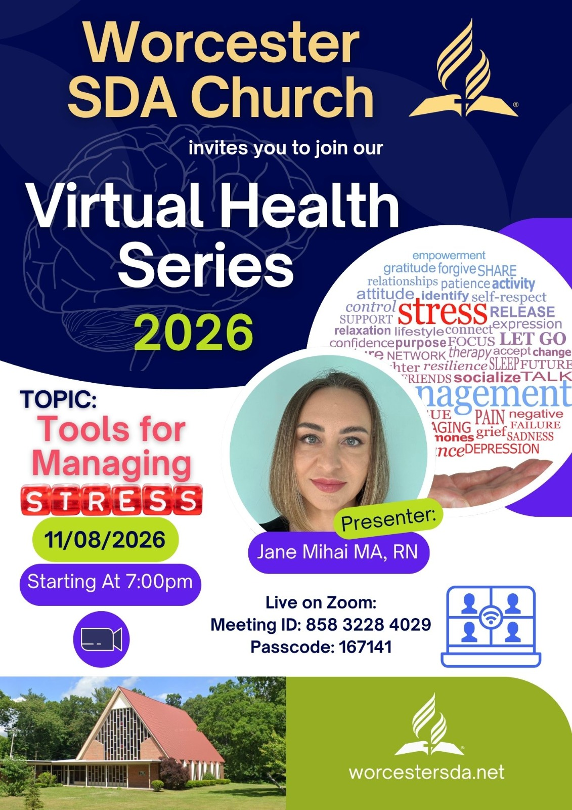

CONFERENCE




