WELCOME TO
PLEASANT STREET SDA CHURCH
A Welcoming Place for All, Fostering Discipleship
SABBATH SCHOOL
OCTOBER 17, 2026
🙤 Bible Study 🙤 Fellowship 🙤 Outreach 🙤 World Mission 🙤
🙤 Praise and Worship 🙤 Praise Team

🙤 Opening Song 🙤 Hymn #529
“Under His Wings”

🙤 Opening Prayer 🙤 Superintendent

🙤 Welcome 🙤 Superintendent

🙤 Scripture Reading 🙤 Congregation
Jeremiah 14:7-10, KJV

🙤 Church at Study 🙤

Old Testament Prophets

🙤 Mission Emphasis 🙤 Video
Change My Life

🙤 Questions to Ponder 🙤
How can we cultivate a heart that listens, and responds, to God’s message, rather that resists it, as many in Isreal did?

🙤 Closing Remarks 🙤
A true prophet comes from within the covenant community, “from your brothers” – (Deut. 18:15, ESV), ensuring a connection to God’s people. Although God can speak through anyone, as with Balaam’s donkey, he typically raises prophets from within His faithful community. Prophets acted as messengers, conveying God’s commands without adding personal opinions.
– Eric J. Tully

🙤 Closing Song 🙤 Hymn #309
“I Surrender All”

🙤 Closing Prayer 🙤 Volunteer

WORSHIP SERVICE
11:00AM

Praise and Worship Praise Team

Hymn of Adoration Hymn #10
“Come, Christians, Join to Sing”

Intercessory Prayer Annette Danville

Greetings and Ministry Highlights Clerk

Welcome Scott Speaks

Children’s Presentation

Special Music Combined Choir

Scripture Reading
Acts 20:32

Worship in Giving Karen Zeno
Local Church Budget

Introduction of Speaker Karen Zeno

Appreciation Gift & Family Recognition

Prayer of Blessing

Meditation Pleasant Street Men’s Group

Sermon Pastor John K. Amoah
I Commend You to God

Hymn of Consecration Hymn #103
“O God, Our Help”

Prayer of Consecration Pastor John K. Amoah

LOOKING AHEAD

FAMILY OF THE WEEK
Today – Kukome Family
10/24 – Debra Lalloo
10/31 – Lockhart Family

SICK/SHUT-IN
Majrie Thompson
Valdine Pyatt – RegalCare at Worcester
Angel Hampton – RegalCare at Worcester
Ivy Forbes – Reservoir Healthcare, Marlborough
John Piscione – Odd Fellows Home, Worcester

TREASURY CORNER
Members are encouraged to utilize online giving as the primary means of giving. Visit the church website at https://www.pleasantstreetsda.org/ select “Give” on the top menu bar or via the Adventist Giving Website at
https://adventistgiving.org/#/org/AN4MLG/envelope/start.

Members can mail their checks to our PO Box:
Pleasant Street SDA Church
PO Box 20929
West Side Station
Worcester, MA 016

BULLETIN CORNER
Please submit bulletin information to psdabulletin@gmail.com.
All information is due by Tuesday of each week.

BABY BLESSING
Baby Blessings conducted by the Pastor are scheduled for the 3rd Sabbath of each month. Please get in touch with the church clerk for further information.

DIRECTORY
Pastor | John K. Amoah | 508-410-2414
Head Elder | Milton Wright | 508-887-6524
Church Clerk | Myrna Campbell-Claxton | 508-847-0115
Head Deacon | Paul Bastien | 301-928-3250
Head Deaconess | Winnefred Fearon | 508-752-9490

DEPARTMENT NEWS

OCTOBER EVENTS
Today - Pathfinder Investiture Service @ 3pm
18th – Pathfinder Club Meeting
24th – No local Church Service at Pleasant Street
24th – Church Trip to William Miller Farm, New York
25th – Adventurer Club Meeting

OCTOBER BIRTHDAYS
Yvonne Jenkins (1), Esther NgaNga (1), Jason Johnson (4), Caleb Ogunjobi (9), Valdine Pyatt (18), Patrick Chambers (24), Nathan Danville (26), Angel Hampton (29), Milton Wright (30)

Did we miss you? If your birthday was not listed and you would like it to be, please submit a note to one of the Clerks.

OCTOBER OFFERING SCHEDULE
Today – Local Church Budget
10/24 – Local Conference Advance
10/31 – Adventist Community Services (Atlantic Union Conference)

MEMBERS ON DUTY
Elder – Karen Zeno
Superintendent – Kristina Vassell
Deacons – Anthony Thomas, Darley Artey
Deaconesses – Brenda Wright, Comfort Matale
Ushers/Greeters – Ewan Richards, Guiriana Meunier

TREASURY INFORMATION
100% of the Tithe Goes to the Conference

Church Financial Snapshot | September 2026
Tithe Received | $256,305.02 (Year To Date)
Tithe Received in September | $27,354.94
Combined Budget Received in September | $1,177.82
Expenses in September | $9, 490.24
Deficit for September | (8,312.35)

ZOOM MEETING INFORMATION

PS-SDA Church Service
Time: Every Sabbath 9:30 AM Eastern Time (US and Canada)
Join Zoom Meeting
https://zoom.us/j/96683645613?pwd=ME5IMnpPVlM3VDZUa2Z1QkpxZ1BCdz09

Meeting ID: 966 8364 5613
Password: 970992

Phone: 1-929-205-6099

PS-SDA Prayer Meeting
Time: Every week on Wednesday at 7:00 PM Eastern Time (US and Canada)
Join Zoom Meeting
https://zoom.us/j/93236151870?pwd=c2hGL29TSUxtRDFqSkJNdzhIa0JRQT09

Meeting ID: 932 3615 1870
Password: 234741

Phone: 1-929-205-6099

Child Safety is of the utmost importance in our Church community. The Southern New England Conference participates in Shield the Vulnerable, a program that focuses on reducing potential dangers to children.
- Background checks are conducted for each person working with our children including Sabbath School, Adventurers and Pathfinders.
- Children are to be escorted by their guardian.
- Two adults are needed in each Sabbath School class (except Beginners where parents are present).

Sunset Today – 6:03pm Sunset on Friday 5:52pm



ONLY A FEW SEATS REMAIN!
Don’t miss our church family trip to the William Miller Farm on Sabbath, October 24! Only a couple of seats remain on the coach bus.
Cost: $50 per person if registered AND paid after October 17.
Please remember that signing up does not secure your seat until payment is received. See a church leader to make your payment and reserve your seat. First come, first served!

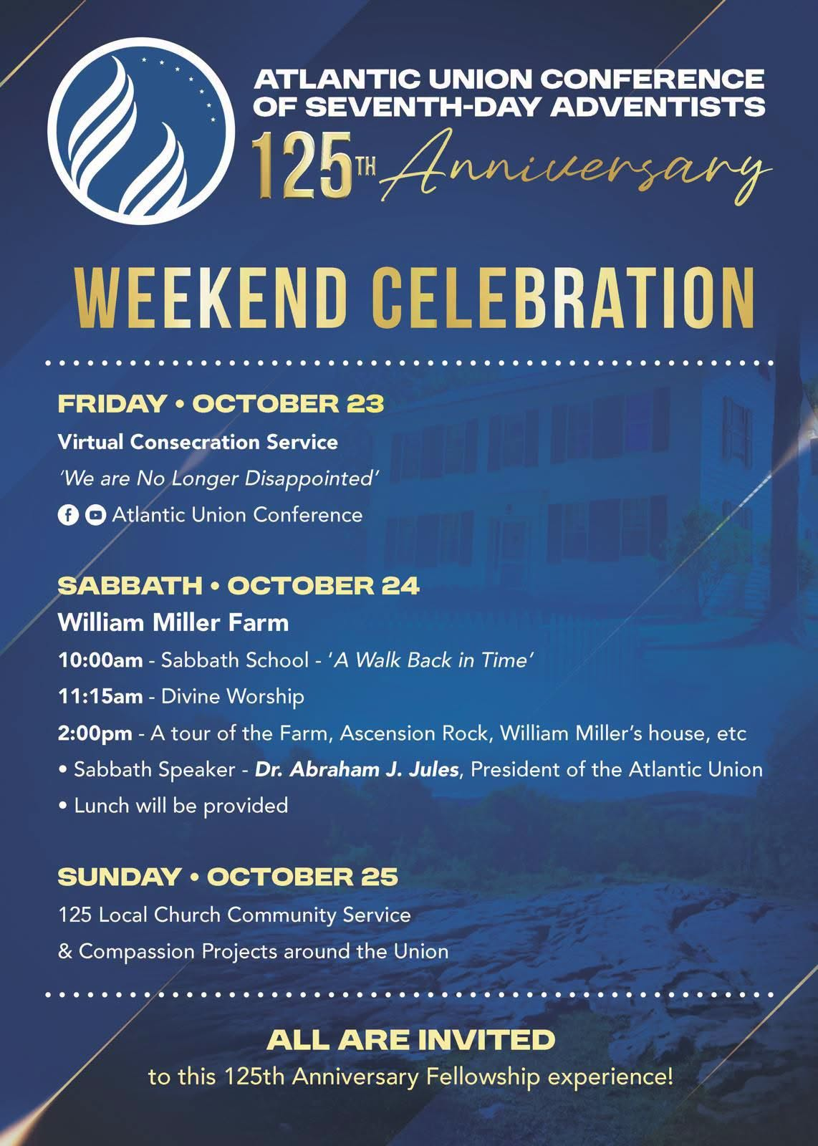

PERSONAL MINISTRY



Pleasant Street Seventh Day Adventist Church

Prison Ministry Department

Invites you to Participate in the

Angel Tree Program
Unwrap the Joy

When Mom, Dad or Family Member goes to prison, a child may feel lonely and forgotten. Especially around the holidays. Share the hope of Jesus with a hurting child in your community as you deliver a Holiday gift and a personal message of love on behalf of their parent or family member in prison.

It starts with a gift and leads to restored lives.

*** MORE INFORMATION COMING SOON***


Wear Pink for Breast Cancer Awareness Sabbath!
On Sabbath, October 31, we invite our entire Pleasant Street church family—men, women, youth, and children—to wear pink as we unite in raising breast cancer awareness, honoring survivors, remembering loved ones, and supporting those affected. Together, let's spread hope, encourage early detection, and demonstrate Christ's love and compassion. Wear pink and stand together in faith, hope, and healing!

Worcester Doves of Peace Pathfinder Club
and
Bluebirds of Happiness Adventurer Club
Investiture Service
October 17, 2026
3:00 pm

Procession Drum Corps, Color Guards
Pathfinders, Adventurers

Pathfinder/Adventurer Pledge and Law Pathfinders & Adventurers
Pledge of Allegiance
Adventurer Law
Adventurer Pledge
Pathfinder Pledge to The Bible
Pathfinder Pledge
Pathfinder Law.

Adventurer/Pathfinder Song Pathfinders & Adventurers

Greetings Area Coordinator Elisa Bravo

Prayer Samara Tang-Rainwater & Oliver Paradise

Welcome Adventurer Delcardo Minott

Special Music Adventurer Sarah Mayson

Practical Demonstrations of classes Adventurers/Pathfinders

Adventurers Little Lambs Counselor Candace Vanhorne
Director Erica Whyte
Eager Beavers Counselor Jessica Smith
Busy Bees Counselor Ishea Allen
Sunbeams Counselor Sasheyra Foster
Builders Deputy Director Mark Morana
Helping Hands Counselor Vivienne Morana

PATHFINDER Friends Deputy Director Paul Bastien
Companions Counselor Say Tang-Rainwater
Explorers Counselor Brenda Wright
Rangers Counselor Mark Belfort
Voyagers Counselor Erica Gibson
Guides Counselor David Melville
TLT’s Deputy Director Paul Vassell

Certification of Candidates Director Ann-Marie Clue-Melville
Coordinator Elisa Bravo
Class Instructors
TLT Certification Deputy Director Paul Vassell

Recognition Director Ann-Marie Clue-Melville
Deputy Director Paul Bastien
Director Erica Whyte
Deputy Director Mark Morana

Introduction of Speaker Pathfinder Nylah Nderitu

Scripture Reading Pathfinder Nylah Nderitu
Jeremiah 29:11-12

Charge & Challenge Pathfinder Ahijah Mathieson
“God is the Guide”

Introduction of Speaker Pathfinder Kweku Kaffour

Scripture Reading Pathfinder Kweku Kaffour
2 Kings 6:16

Charge & Challenge Elisa Bravo, Area Coordinator
“No Doubt We Are Not Alone”

Special Music Pathfinders Justin Nazaire
Jaida and Joshua Johnson

Announcements Deputy Director Paul Bastien

Year in Review Video

Consecration & Dedication Prayer Pastor John K Amoah

