WELCOME TO
PLEASANT STREET SDA CHURCH
A Welcoming Place for All, Fostering Discipleship
SABBATH SCHOOL
OCTOBER 10, 2026
🙤 Bible Study 🙤 Fellowship 🙤 Outreach 🙤 World Mission 🙤
🙤 Praise and Worship 🙤 Praise Team

🙤 Opening Song 🙤 Hymn #520
“He Hideth My Soul”

🙤 Opening Prayer 🙤 Superintendent

🙤 Welcome 🙤 Superintendent

🙤 Scripture Reading 🙤 Congregation
Daniel 1:12-16, KJV

🙤 Church at Study 🙤

The Call of a Prophet

🙤 Mission Emphasis 🙤 Video
Every Step a Battle

🙤 Questions to Ponder 🙤
- How does knowing that God uses ordinary people for extraordinary purposes encourage your faith?
- How can we be messengers of God’s justice and mercy in a world that struggles with the extremes of both?

🙤 Closing Remarks 🙤
Prophets were “chosen by God to receive his message and then to proclaim it to an audience in a particular historical situation.”
– Eric J. Tully

🙤 Closing Song 🙤 Hymn #590
“Trust and Obey“

🙤 Closing Prayer🙤 Volunteer
WORSHIP SERVICE
11:00AM

Praise and Worship Praise Team

Hymn of Adoration Hymn #316
“Live Out Thy Life Within Me”

Intercessory Prayer Frances Grant

Greetings and Ministry Highlights Clerk

Welcome Brenda Wright

Children’s Story Mark Morana

Special Music Douglas McCleary

Worship in Giving Karen Zeno
Disaster & Famine Relief (Atlantic Union Conference)

Introduction of Speaker Karen Zeno

Scripture Reading Abby Alers
Romans 8:3-4

Meditation Douglas McCleary

Sermon Milton Wright
Grace-Empowered Obedience

Hymn of Consecration Hymn #590
“Trust and Obey”

Prayer of Consecration Milton Wright

LOOKING AHEAD

FAMILY OF THE WEEK
Today – Samuel Joseph
10/17 – Kukome Family
10/24 – Debra Lalloo
10/31 – Lockhart Family

SICK/SHUT-IN
Majrie Thompson
Valdine Pyatt – RegalCare at Worcester
Angel Hampton – RegalCare at Worcester
Ivy Forbes – Reservoir Healthcare, Marlborough
John Piscione – Odd Fellows Home, Worcester

TREASURY CORNER
Members are encouraged to utilize online giving as the primary means of giving. Visit the church website at https://www.pleasantstreetsda.org/ select “Give” on the top menu bar or via the Adventist Giving Website at
https://adventistgiving.org/#/org/AN4MLG/envelope/start.

Members can mail their checks to our PO Box:
Pleasant Street SDA Church
PO Box 20929
West Side Station
Worcester, MA 016

BULLETIN CORNER
Please submit bulletin information to psdabulletin@gmail.com.
All information is due by Tuesday of each week.

BABY BLESSING
Baby Blessings conducted by the Pastor are scheduled for the 3rd Sabbath of each month. Please get in touch with the church clerk for further information.

DIRECTORY
Pastor | John K. Amoah | 508-410-2414
Head Elder | Milton Wright | 508-887-6524
Church Clerk | Myrna Campbell-Claxton | 508-847-0115
Head Deacon | Paul Bastien | 301-928-3250
Head Deaconess | Winnefred Fearon | 508-752-9490

DEPARTMENT NEWS

OCTOBER EVENTS
11th – Adventurer Club Meeting
11th – Diaper Ministry Distribution
11th – Church Board Meeting
17th – Pathfinder Investiture Service
18th – Pathfinder Club Meeting
24th – No local Church Service at Pleasant Street
24th – Church Trip to William Miller Farm, New York
25th – Adventurer Club Meeting

OCTOBER BIRTHDAYS
Yvonne Jenkins (1), Esther NgaNga (1), Jason Johnson (4), Caleb Ogunjobi (9), Valdine Pyatt (18), Patrick Chambers (24), Nathan Danville (26), Angel Hampton (29), Milton Wright (30)

Did we miss you? If your birthday was not listed and you would like it to be, please submit a note to one of the Clerks.

OCTOBER OFFERING SCHEDULE
Today – Disaster & Famine Relief (Atlantic Union Conference)
10/17 – Local Church Budget
10/24 – Local Conference Advance
10/31 – Adventist Community Services (Atlantic Union Conference)

MEMBERS ON DUTY
Elder – Karen Zeno
Superintendent – Kristina Vassell
Deacons – David Gogo, Claude Beckford, Nahum Minott
Deaconesses – Winnifred Fearon, Erica Whyte
Ushers/Greeters – Candace Vanhorne, Paula St. Helene

TREASURY INFORMATION
100% of the Tithe Goes to the Conference

Church Financial Snapshot | September 2026
Tithe Received | $256,305.02 (YTD)
Tithe Received in September | $27,354.94
Combined Budget Funds | $115,654.29 (YTD)
Combined Budget in September | $1,177.82
Expenses in September | $9, 490.24
Deficit | ($22,460.88)

ZOOM MEETING INFORMATION

PS-SDA Church Service
Time: Every Sabbath 9:30 AM Eastern Time (US and Canada)
Join Zoom Meeting
https://zoom.us/j/96683645613?pwd=ME5IMnpPVlM3VDZUa2Z1QkpxZ1BCdz09

Meeting ID: 966 8364 5613
Password: 970992

Phone: 1-929-205-6099

PS-SDA Prayer Meeting
Time: Every week on Wednesday at 7:00 PM Eastern Time (US and Canada)
Join Zoom Meeting
https://zoom.us/j/93236151870?pwd=c2hGL29TSUxtRDFqSkJNdzhIa0JRQT09

Meeting ID: 932 3615 1870
Password: 234741

Phone: 1-929-205-6099

Child Safety is of the utmost importance in our Church community. The Southern New England Conference participates in Shield the Vulnerable, a program that focuses on reducing potential dangers to children.
- Background checks are conducted for each person working with our children including Sabbath School, Adventurers and Pathfinders.
- Children are to be escorted by their guardian.
- Two adults are needed in each Sabbath School class (except Beginners where parents are present).

Sunset Today – 6:14pm Sunset on Friday 6:03pm

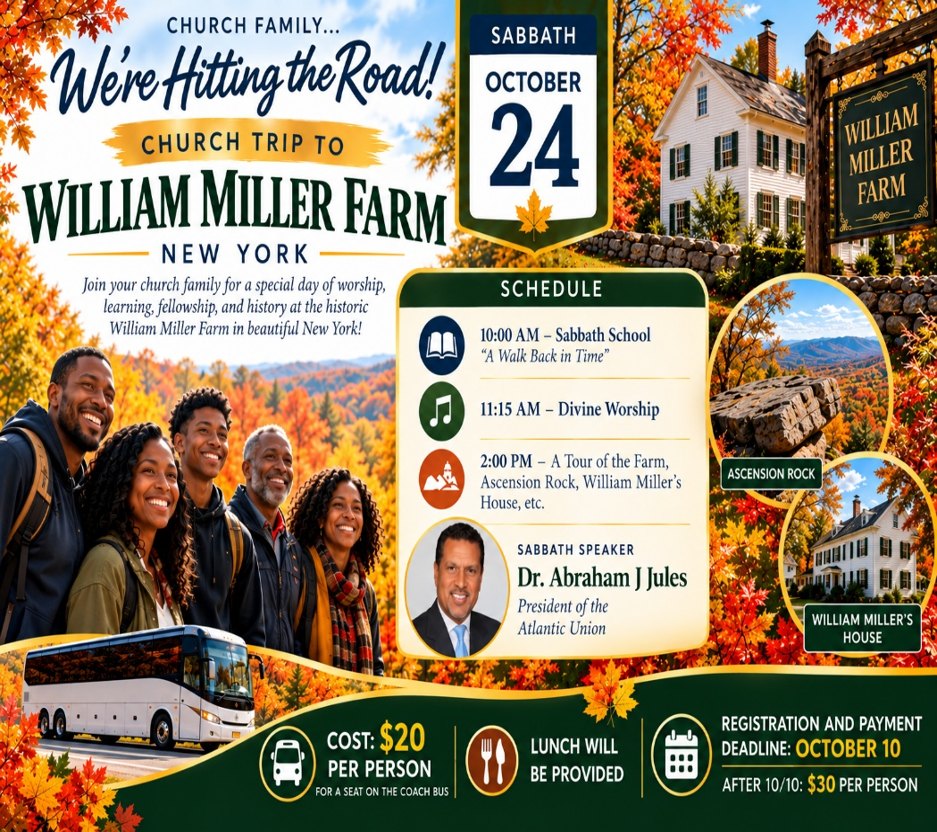

ONLY A FEW SEATS REMAIN!
Don’t miss our church family trip to the William Miller Farm on Sabbath, October 24! Only a couple of seats remain on the coach bus.
Cost: $20 per person if registered AND paid by October 10.
After October 10: $30 per person.
Please remember that signing up does not secure your seat until payment is received. See a church leader to make your payment and reserve your seat. First come, first served!

PERSONAL MINISTRY

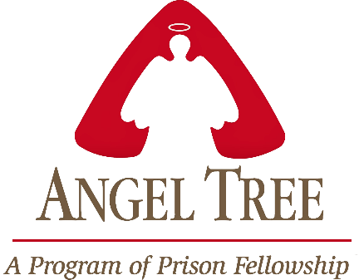

Pleasant Street Seventh Day Adventist Church

Prison Ministry Department

Invites you to Participate in the

Angel Tree Program
Unwrap the Joy

When Mom, Dad or Family Member goes to prison, a child may feel lonely and forgotten. Especially around the holidays. Share the hope of Jesus with a hurting child in your community as you deliver a Holiday gift and a personal message of love on behalf of their parent or family member in prison.

It starts with a gift and leads to restored lives.

*** MORE INFORMATION COMING SOON***

HEALTH MINISTRY
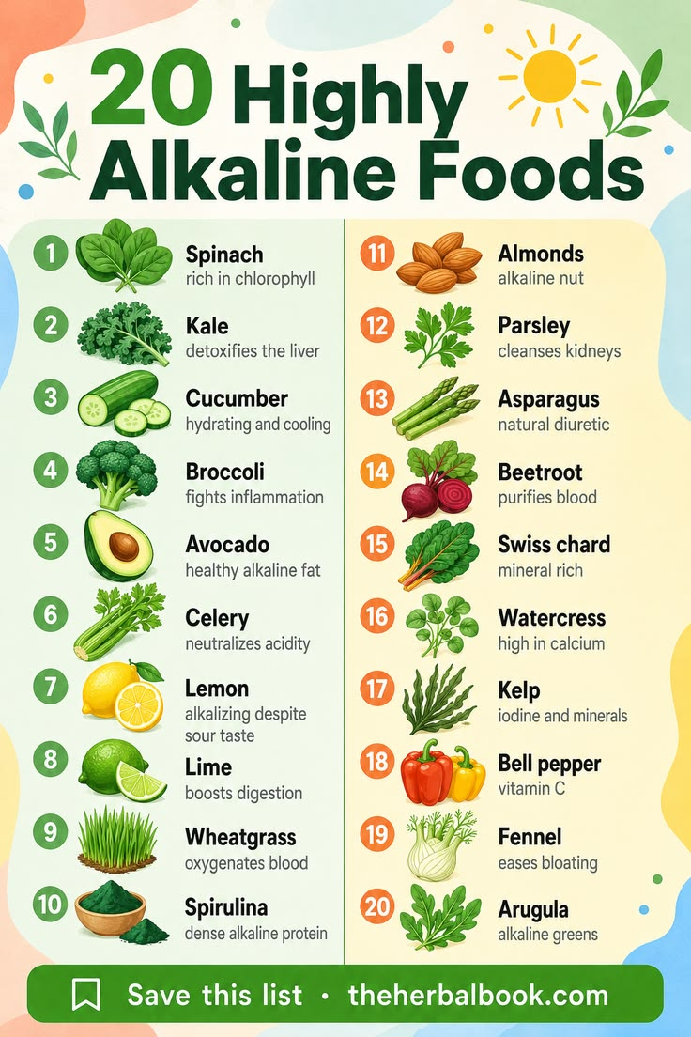

CONFERENCE EVENT

