SABBATH SCHOOL
OCTOBER 3, 2026
🙤 Bible Study 🙤 Fellowship 🙤 Outreach 🙤 World Mission 🙤
🙤 Praise and Worship 🙤 Praise Team

🙤 Opening Song 🙤 Hymn #524
“’Tis So Sweet to Trust in Jesus”

🙤 Opening Prayer 🙤 Superintendent

🙤 Welcome 🙤 Superintendent

🙤 Scripture Reading 🙤 Congregation
Isaiah 59:2, KJV

🙤 Church at Study 🙤

The Creator Speaks

🙤 Mission Emphasis 🙤 Video
Finding Family on the Streets of Helsinki

🙤 Questions to Ponder 🙤
- In what way does God communicate with us today?
- How can we become more attentive to His voice?

🙤 Closing Remarks 🙤
Adam and Eve were created in a perfect world beyond our fondest imaginations. The Garden of Eden was the sacred dwelling place of God’s presence on earth. As the triune God is inherently relational, He created human beings in His image in order to reflect this relational nature. His greatest gift to unfallen humanity was the capacity to engage with His in personal and relational communion. Adam and Eve thus enjoyed direct, face-to-face fellowship with God in this perfect setting.

🙤 Closing Song 🙤 Hymn #100
“Great is Thy Faithfulness”

🙤 Closing Prayer 🙤 Volunteer
WORSHIP SERVICE
11:00AM

Praise and Worship Praise Team

Hymn of Adoration Hymn #1
“Praise to the Lord”

Intercessory Prayer Marcia King

Greetings and Ministry Highlights Clerk

Welcome Eby Martineau

Children’s Story Video

Worship in Giving
Local Church Budget

Introduction of Speaker Karen Zeno

Scripture Reading Sarah Agulu
Exodus 33:12–17

Meditation Nahum Minott

Sermon Pastor John K. Amoah
Praying Us Home

Hymn of Consecration Hymn #71
“Come Thou Almighty King”

Prayer of Consecration Pastor John K. Amoah

LOOKING AHEAD

FAMILY OF THE WEEK
Today – Keon Johnston
10/10 – Samuel Joseph
10/17 – Kukome Family
10/24 – Debra Lalloo
10/31 – Lockhart Family

SICK/SHUT-IN
Majrie Thompson
Valdine Pyatt – RegalCare at Worcester
Angel Hampton – RegalCare at Worcester
Ivy Forbes – Reservoir Healthcare, Marlborough
John Piscione – Odd Fellows Home, Worcester

TREASURY CORNER
Members are encouraged to utilize online giving as the primary means of giving. Visit the church website at https://www.pleasantstreetsda.org/ select “Give” on the top menu bar or via the Adventist Giving Website at
https://adventistgiving.org/#/org/AN4MLG/envelope/start.

Members can mail their checks to our PO Box:
Pleasant Street SDA Church
PO Box 20929
West Side Station
Worcester, MA 016

BULLETIN CORNER
Please submit bulletin information to psdabulletin@gmail.com.
All information is due by Tuesday of each week.

BABY BLESSING
Baby Blessings conducted by the Pastor are scheduled for the 3rd Sabbath of each month. Please get in touch with the church clerk for further information.

DIRECTORY
Pastor | John K. Amoah | 508-410-2414
Head Elder | Milton Wright | 508-887-6524
Church Clerk | Myrna Campbell-Claxton | 508-847-0115
Head Deacon | Paul Bastien | 301-928-3250
Head Deaconess | Winnefred Fearon | 508-752-9490

DEPARTMENT NEWS

OCTOBER EVENTS
4th – Pathfinder Club Meeting
11th – Adventurer Club Meeting
11th – Diaper Ministry Distribution
11th – Church Board Meeting
17th – Pathfinder Investiture Service
18th – Pathfinder Club Meeting
24th – No local Church Service at Pleasant Street
24th – Church Trip to William Miller Farm, New York
25th – Adventurer Club Meeting

SEPTEMBER BIRTHDAYS
Marlene Tyrell (2), Janae Marie Johnson (7), Chauncey James-Moore (10), May Forbes (13), James Turay (21), James Vassell (22), Daphne Miller (25), Claudine Morana (28), Jasmine Tyrell (28), Samara Tang-Rainwater (28)

Did we miss you? If your birthday was not listed and you would like it to be, please submit a note to one of the Clerks.

OCTOBER OFFERING SCHEDULE
Today – Local Church Budget
10/10 – Disaster & Famine Relief (Atlantic Union Conference)
10/17 – Local Church Budget
10/24 – Local Conference Advance
10/31 – Adventist Community Services (Atlantic Union Conference)

MEMBERS ON DUTY
Elder – Karen Zeno
Superintendent – Kristina Vassell
Deacons – Paul Bastien, Clyde Vanhorne, Paul Smith
Deaconesses – Brenda Mwansa-Kamombo, Madrina Smith
Ushers/Greeters – Annette Danville, Guiriana Meunier

TREASURY INFORMATION

Church Financial Snapshot | Year to Date as of August 2026
Tithe Received | $228,950.08
Combined Budget Funds | $81,015.99
Expenses | ($106,165.05)
Deficit | ($25,149.06)

ZOOM MEETING INFORMATION

PS-SDA Church Service
Time: Every Sabbath 9:30 AM Eastern Time (US and Canada)
Join Zoom Meeting
https://zoom.us/j/96683645613?pwd=ME5IMnpPVlM3VDZUa2Z1QkpxZ1BCdz09

Meeting ID: 966 8364 5613
Password: 970992

Phone: 1-929-205-6099

PS-SDA Prayer Meeting
Time: Every week on Wednesday at 7:00 PM Eastern Time (US and Canada)
Join Zoom Meeting
https://zoom.us/j/93236151870?pwd=c2hGL29TSUxtRDFqSkJNdzhIa0JRQT09

Meeting ID: 932 3615 1870
Password: 234741

Phone: 1-929-205-6099

Child Safety is of the utmost importance in our Church community. The Southern New England Conference participates in Shield the Vulnerable, a program that focuses on reducing potential dangers to children.
- Background checks are conducted for each person working with our children including Sabbath School, Adventurers and Pathfinders.
- Children are to be escorted by their guardian.
- Two adults are needed in each Sabbath School class (except Beginners where parents are present).

Sunset Today – 6:26pm Sunset on Friday 6:14pm

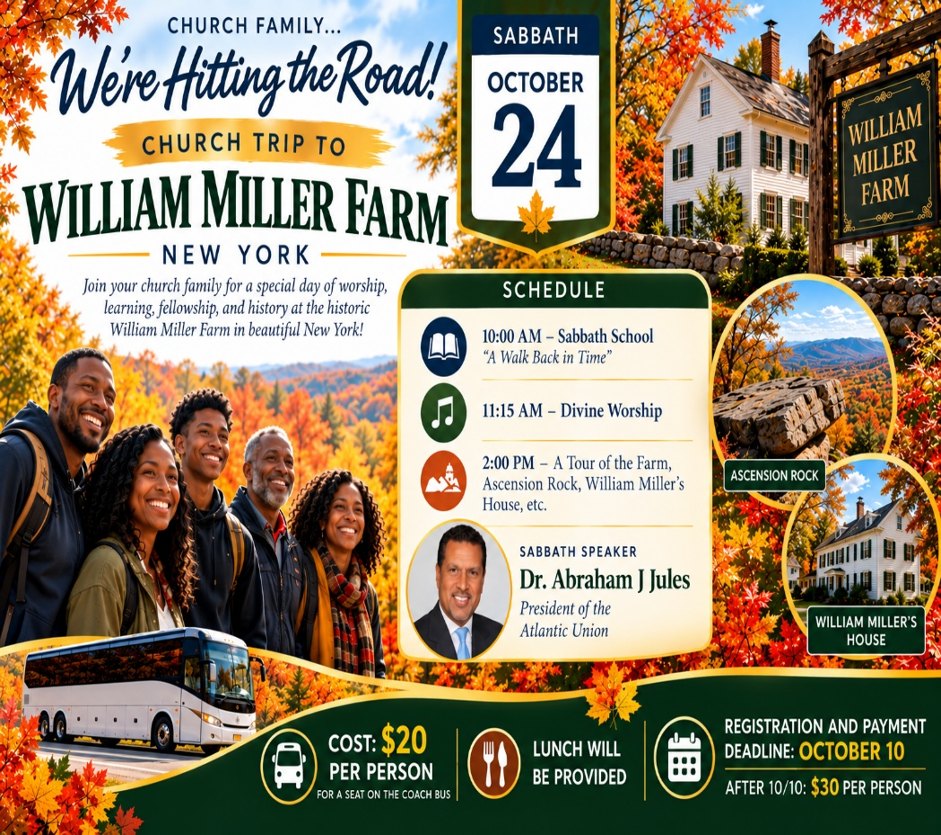

ONLY A FEW SEATS REMAIN!
Don’t miss our church family trip to the William Miller Farm on Sabbath, October 24! Only a couple of seats remain on the coach bus.
Cost: $20 per person if registered AND paid by October 10.
After October 10: $30 per person.
Please remember that signing up does not secure your seat until payment is received. See a church leader to make your payment and reserve your seat. First come, first served!

PERSONAL MINISTRY

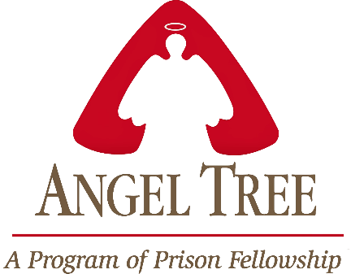

Pleasant Street Seventh Day Adventist Church

Prison Ministry Department

Invites you to Participate in the

Angel Tree Program
Unwrap the Joy

When Mom, Dad or Family Member goes to prison, a child may feel lonely and forgotten. Especially around the holidays. Share the hope of Jesus with a hurting child in your community as you deliver a Holiday gift and a personal message of love on behalf of their parent or family member in prison.

It starts with a gift and leads to restored lives.

*** MORE INFORMATION COMING SOON***

HEALTH MINISTRY
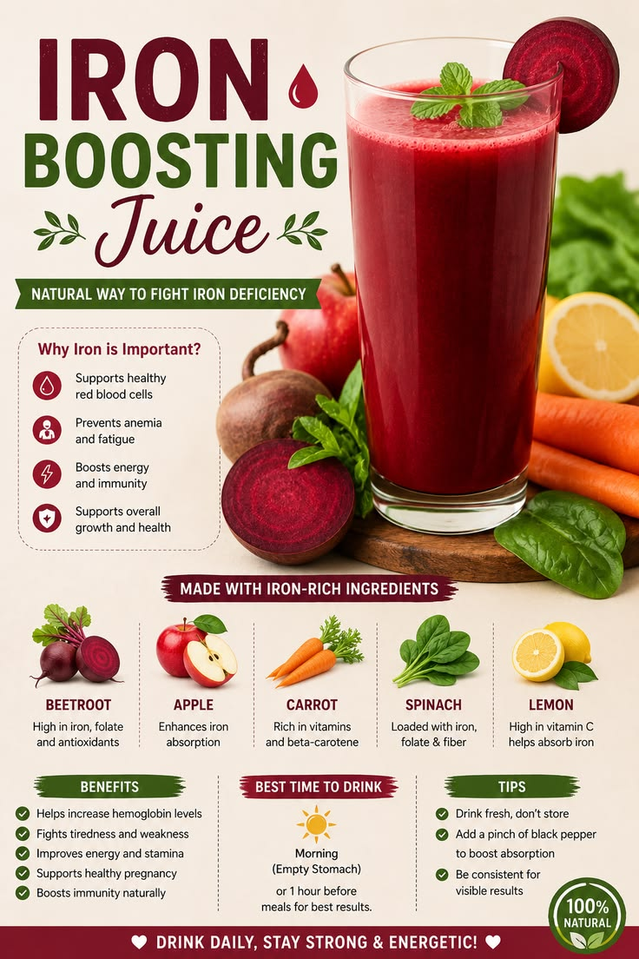
Iron Boosting Juice Recipe | Natural Drink to Increase Iron & Energy
Description
Boost your iron levels naturally made with beetroot, spinach, apple, carrots, and lemon. Rich in iron, folate, antioxidants, and vitamin C. The refreshing drink also helps support healthy hemoglobin levels, improve energy, reduce fatigue, and promote overall health

CONFERENCE EVENT

