

Supply List 2026-2027
Below is a basic list of supplies that will be needed by your child/children for the opening of the 2025-2026 school year. These items will need to be replaced periodically throughout the year. A reminder will be sent home when the supplies need to be replenished. If for some reason you are unable to provide these supplies, please let the teacher know.

Everyone Needs these Items
Headphones
A personal set of headphones or earbuds (no earbuds for K-2) in a Ziplock bag labeled with student’s name.

Personal Water Bottle with Sipper Top
All students will need a reusable water bottle with a sipper top. Must be taken home and cleaned daily. Please make sure that the child’s name is printed on it.

Book Bag/Backpack
Purchasing a book bag/backpack is a necessary item for all grade levels. It is important that each child has one, as it does protect the textbooks and papers to and from school. Please make sure that the child’s name is printed on it.

Lunchbox
Purchasing a lunchbox is a necessary item for all grade levels. It is important that each child has one. Please make sure that the child’s name is printed on it.

Grades K – 2:
- 1 set of clothes to leave at school, in a labeled Ziploc bag
- 1 paint shirt
- 1 package of 24 count colored Crayola pencils
- 1 container Clorox wipes

***Due to some very generous donors, those supplies listed below do not need to be purchased this year.***
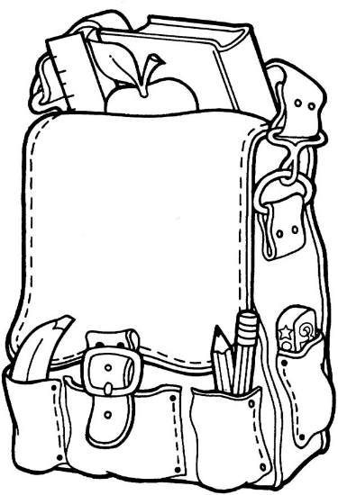
Distributed as Needed
- 1 box of Crayola crayons
- 1 box of 10 Crayola washable markers
- 12 Elmer’s glue sticks
- 24 Ticonderoga pencils (they last longest)
- 1 box gallon Ziploc style bags
- 1 set of watercolor paints
- 1 pair of Fiskers scissors
- 2 primary journals (K-2 version)
Grades 3 – 8: Mrs. Wendt
  - 1 package of 24 count colored Crayola pencils
  - 1 container Clorox wipes
  - 3 refillable mechanical pencils with additional lead and erasers (if not using traditional pencils)

***Due to some very generous donors, those supplies listed below do not need to be purchased this year.***
  - school box/container for supplies – must fit in desk
  - 5 two-pocket folders with prongs (1 each red, blue, yellow, orange, and purple)
  - 2 composition books (black and white marble cover)
  - 1 scissors
Distributed as Needed
  - 1 box of 10 Crayola washable markers
  - 4 glue sticks
  - 1 package Ticonderoga pencils (they last longest)
  - 2 boxes tissues

