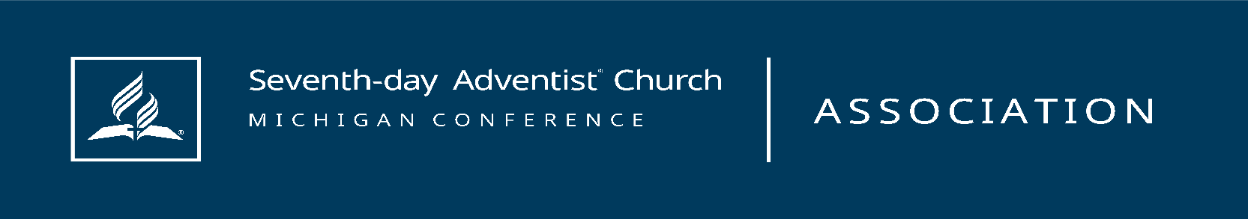
Michigan Conference of Seventh-day Adventist
Enhanced Church Safety Framework
Two Level Church Safety Framework
Level one must be completed before progressing to level two.

LEVEL 1
Completion of the Following:
- Church Board Approval of the Safety Framework
- Designated Safety Officer in place
- Established Safety Committee organized around fire, medical, security, and facility safety domains
- Completed Adventist Risk Management Church Self-Survey form
- Congregation trained by a Michigan Conference Safety Trainer, or for key ministry leaders in larger churches
- Completed walkthrough of all buildings with local law enforcement, with recommendations formally presented to and voted on by the Church Board
- Emergency Procedures Document in place
- Basic First Aid and Stop the Bleed Training for key ministry leaders
- Assessment completed for potential camera installation
- Assessment completed for potential use of communication radios
- Any locally voted security team policy must be submitted to the Conference for review and approval prior to implementation.

Committee Members: Joel Nephew, Brian Kittleson, Kevin Lehmann, Michael Tan, and Mona Hickman

LEVEL 2
Armed personnel committed to eliminating active threat. Level 2 personnel must be dedicated to the training required to maintain their proficiency with the pistol. Concealed carry only, with a minimum of one (1) hour of documented range time per quarter.
TRAINING
- Training will include decision-making, identifying threats and level of force needed
- Demonstrated effective verbal communication and de-escalation skills
- Demonstrated ability to safely and effectively shoot while moving
- Demonstrated ability to engage moving targets
- Demonstrated proficiency using multiple shooting positions
- Demonstrated ability to perform under stress
- Demonstrated ability to shoot effectively from cover
- Refer to appendix A
Appendix A
Requirements to carry a concealed pistol in church:
- Being a CPL holder
- Individual liability insurance - (ensure that volunteer church security members are not excluded)
- Advanced pistol training in the use of deadly force in a public assembly area
- Michigan Coalition of Law Enforcement Standards (MCOLES) or FBI pistol qualification – annually
- Other pistol training (e.g., scenario-type training; MILO digital simulator) semi-annually.
- Adventist Screening Verification background check
- CPL holder’s firearm inspected annually by the church Safety Officer, consisting of a basic function check and verification of approved caliber; armorer-level inspection is not required.
- Weapon caliber suggested – 9mm, .40, .357 or .45 - standard or compact
- Defensive ammunition only, defined as factory-manufactured hollow-point ammunition; self-loaded or reloaded ammunition is not permitted.
- The firearm used for qualification is the same firearm authorized for carry during church activities.

