Stewardship and Mission

Sept05- Sept11 Memory Text:
“For you know the grace of our Lord Jesus Christ, that though He was rich, yet for your sakes He became poor, that you through His poverty might become rich" (2 Corinthians 8:9, NKJV).
**********************************************************************
 To Join Church’s Text System: text MERIDENSDA to phone number 84576. A link will be sent you. Click on that link and follow the directions.
To Join Church’s WhatsApp Group: click on link https://chat.whatsapp.com/J4O0TG2xZcHHmHX0wG2Exu.
To join the Church’s Email Distribution List: please send a request to meridensdaweb@gmail.com.
**********************************************************************
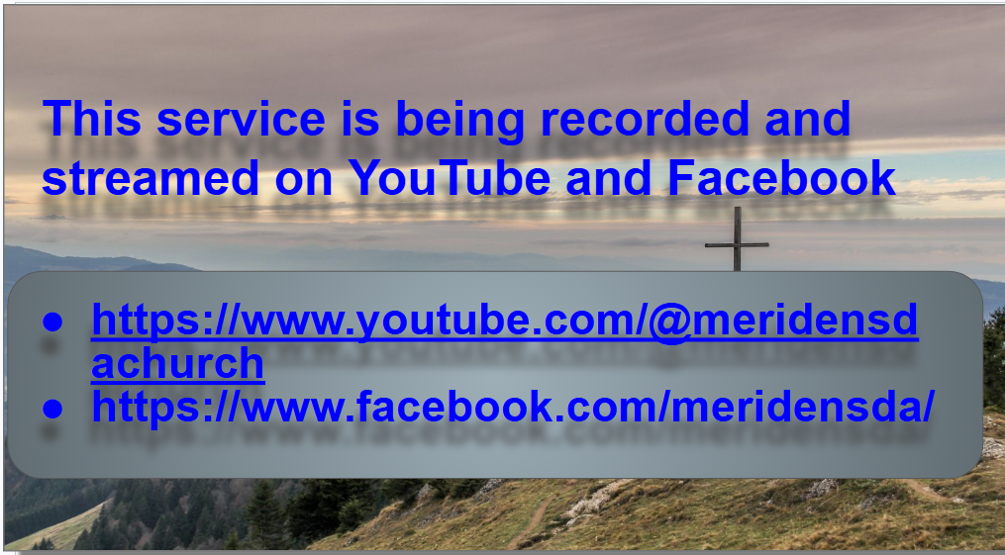
Join us on Zoom We are recording Scan for On-line Giving

Youth SABBATH SCHOOL 9:45 am – 11:00 am
Resource link click the link>> Cornerstone Connections –
Official Youth Sabbath Resources >> https://ssnet.org/other-age-groups/
Zoom https://us02web.zoom.us/ j/87514707104
Adult Sabbath School @10am
Adult Sabbath School Study Guides & More >> https://ssnet.org/study-guides/
** In person meeting~ No zoom provided***
Church Service @ 11:25
MeridenZoom https://us02web.zoom.us/j/3974461365?pwd=S3VjMnVtWGRqS0dsTFR4V3VLSjU4UT09
Meeting ID: 397 446 1365, Password : msda

Meriden Seventh-Day Adventist Church
Saturday September 12th,2026

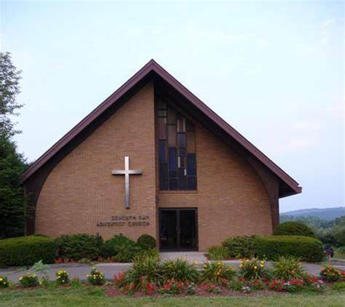
300 Paddock Ave. Meriden, CT.

How Can We Help?
For questions and inquiries, you can contact us at:
Email: Meridensdaweb@gmail.com
Phone: 203.630.3320
Website: http://www.meridensda.org/


We Celebrate you! Need to talk? Requests?

Sunset: 7:05pm Sunset Next Week: 6:53pm

Elder on Duty: Brother Desmond Bulletin Editor: Sister Kimone

September 12, 2026
Sabbath School 10:00am

Sabbath School Pastor John 10:00 am
Personal Ministries Sister April 11: 00 am
Announcements Brother Desmond 11:15 am

Divine Worship Service 11:30 am
Introit:
Hymn #285 Congregation
Surely the presence of the Lord is in this place; I can feel his mighty power and his grace. I can hear the brush of angels’ wings, I see glory in each face, Surely the presence of the Lord is in this place.*
Call to Worship & Invocation: Pastor John Lewis
Opening Song: #12 “ Joyful, Joyful” Congregation

Intercessory Prayer: Brother Desmond
Now, Dear Lord, as we pray, take our hearts and minds far away
From the press of the world all around, To Your throne where grace does abound. May our lives be transform'd by Your love, may our souls be refreshed from above. At this moment, let people everywhere. Join us now as we come to You in prayer.

Tithes & Offerings: ‘World Budget [Emp: Radio Ministries ’
Sister Karen
Hymn #670
We give Thee but Thine own, Whate'er the gift may be;
All that we have is Thine alone, A trust, O Lord, from Thee.

Children’s Story Brother Joel
Scripture Readings: Luke 3:15-16 Sister Karen
Special Music Rebecca and German Lopez

Sermon: “ With the Holy Spirit and Fire” Pastor John Lewis
Closing Song: #258 ‘Baptize Us Anew’ Congregation
Benediction: Pastor John Lewis

Recessional/ Doxology

We Welcome Our Speaker…Pastor John Lewis

Announcements

- Baby Shower Today: please join us on TODAY @ 6:30 pm at 10 Juniper Dr, North Haven for a shower for Arianni and Joseph Pregenzer’s baby boy. Late gifts are welcomed. The baby registry link is https://www.amazon.com/baby-reg/joseph-pregenzer-arianni-mende-october-2026-meriden/6PKQX0C5GQ0N
- Next Board Meeting: Monday, September 21, 6:30.
- 🎟️ We’re Going to Sight & Sound — Are You Ready to Secure Your Seat? Join us as we travel to Sight & Sound Theatres in Lancaster, PA, to see JOSHUA! A $50 deposit will secure your seat. To pay online, visit Meriden SDA Adventist Giving and select Local Offerings → Women’s Ministry. Then Sign In or Continue as a Guest and enter your information so your payment can be properly tracked. Prefer to pay in person? See Sister Grace Miller at church on Sabbath. ⚠️ Only a few tickets remain! If you’re interested in joining us, please register here:👉 Register for the JOSHUA Trip
- Women’s Ministry Events: The Garden of Healing Retreat, Fri, Sept 18. Please see https://www.sneconline.org/events-1/womens-ministries-the-garden-of-healing-retreat.
- Women’s Ministry Events: Nantucket and Cape Cod Churches are having a women’s ministry retreat Oct 2-4. To register,use https://forms.cloud.microsoft/pages/responsepage.aspx?id=DQSIkWdsW0yxEjajBLZtrQAAAAAAAAAAAAMAAMCpL6pUOUNIOTRMNU1USzIwMU9HTkxHQ1kzUkdVUi4u&route=shorturl.
- Friday Evening Prayer: 8:00–9:00 PM Meriden Zoom. Join us on Friday evenings for a special hour of prayer. Let’s close the week and welcome the Sabbath together in faith, unity, and expectation.
Next Week at a Glance:
- Saturday, Sept 12, Pregenzer Baby Shower, 6:30 pm, 10 Juniper Dr, North Haven
- Friday, Remote Prayer Meeting, 8:00 pm, via Zoom
- Sabbath Sept 19, Speaker Pastor John Lewis, Fellowship Lunch



