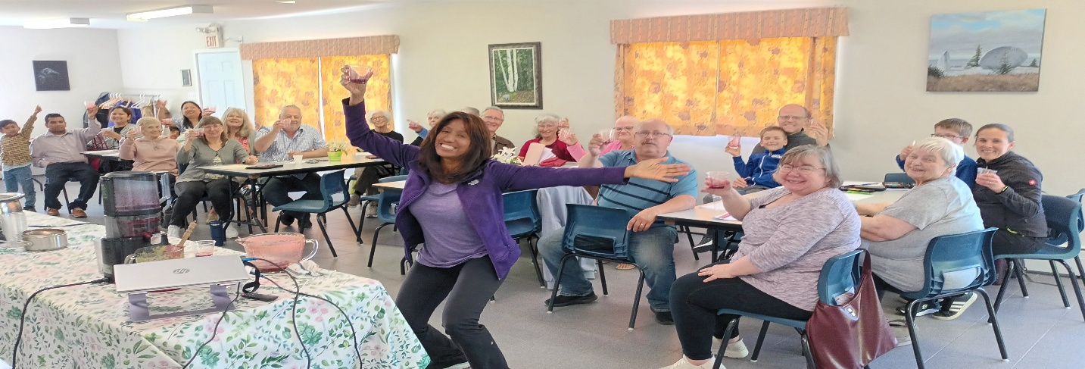
ROOTED IN WELLNESS JUNE 14th, 2026
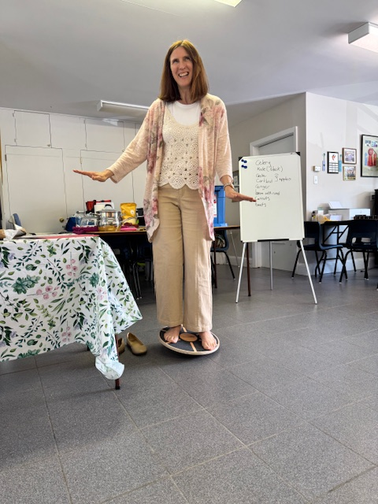
This year we took the Rooted in Wellness Workshop on the road to Tantallon, Nova Scotia and what a blessing it was! We talked about so many interesting practical health initiatives that we can implement into our daily routines. We learned that the intrinsic muscles of the foot can be strengthened by using a wobble board just minutes a day. This simple and inexpensive board improves balance, reflex control, and stability. We were also encouraged to juice. The body benefits greatly. There are so many different vegetable and fruit combinations to be enjoyed! Whole-body vibration otherwise known as the vibrating plate puts a new twist on muscle strengthening, balance, circulation, bone density, and even improving your cognitive function. Just ten minutes a day and your body will thank you! We talked about the importance of a healthy mind and how the brain is the first line of defense against illness. We rebounded our way to great health! NASA’s 1980 study showed that just 10 minutes of rebounding can deliver similar cardiovascular benefits to 30 minutes of jogging! It enhances lymphatic drainage which is vital for healthy immune function. We dove into compresses, poultices, DIY salves, and the importance of caring for your feet! I can’t forget to mention that the food was scrumptious and healthy. Sandy did an amazing job again!
I would like to take this opportunity to thank my side-kick Tarah-Liz! Her enthusiasm when it comes to sharing “health” is quite contagious! Blessings to all who attended.

