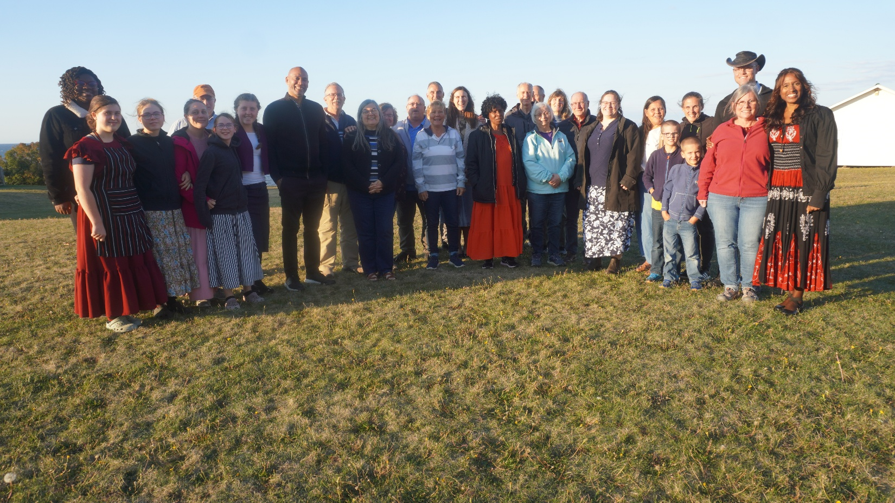

This year’s Rooted in Wellness Workshop was held on Thursday, October 2nd to Sunday, October 5th, 2025 and what a blessing it was to all who participated. We had many professionals: hydrotherapists, massage therapists, naturopaths, and a pharmacognocist to round off the weekend. We learned about the benefits of peat moss, how to make healing salves, why it is important to know how to massage properly, the benefits of knowing the healing power of God’s herbal pharmacy, stretching and why our bodies were built to move, and why it is essential to get acquainted with your ! We dove into the wonderful healing power of grief. Yes, grieving helps us heal! We heard a beautiful testimony on the importance of telling yourself the truth. The food, well, you would have had to be there to understand how we were treated: lip-smacking delicious! The weather was gorgeous-thank you Father, we so very much appreciated that!!! It was an extremely blessed time. The group was like a very large extended family. Thank you to all who came and made this weekend special! See you next year!!! God-willing, of course!
Catherine Walsh
Health Ministries Director

