La Crosse Seventh-day Adventist Church
2117 La Crosse St, La Crosse, WI 5
email: lacrossechurchsda@gmail.com
web: lacrossewi.adventistchurch.org
608-782-4032
Pastor Pedro Luis (608)696-8088
Email couleeregionpastor@gmail

Head Elder is Larry LaSeure (608) 667-6485
Email: larrylasure22@gmail.com
Sabbath May30 ,2026
The Church at Study: 9:30 a.m.
Welcome & Prayer:
Mission Story:
Sabbath School Remarks:
Sabbath School Teacher:Young Adults
Welcome
The Church at Worship: 11:00 a.m.
Congregation Stands
"Praise God from Whom All Blessings Flow,"
Invocation:
*Opening Hymn:
Tithes & Offering:Local Church Budget
Scripture:
Prayer Requests & Praises: Song Before Prayer (kneel)"As We Come” #671 Special Music
Sermon: Young Adults
Closing Song:
Benediction:

Church Mission Statement
“The mission of the La Crosse SDA Church is to proclaim to our communities the good news of the everlasting Gospel, leading them to a deeper relationship with Jesus, while nurturing our membership spiritually, in anticipation of the soon return of our Lord and Savior Jesus Christ.”
Welcome to our Members & Guests!
May God bless each of you abundantly. If you are seeking a church home, please let one of our Elders know. Join us each Sabbath for Fellowship Dinner.
Announcements
Next week’s Offering:Local Church Budget

Next Board Meeting is May 31,2026 at 9:30am

After Potluck join us for Prayer Time
Building
Thank You for your Faithful and Generous Support for our Building Fund.As a result of your commitment, have moved from a deficit of more than $10,000 to a positive balance of $2,075.26 just a few months!! To God be the Glory.
Roof
As many are aware of our section that blew of from our Roof.We are looking to have to replace the whole Roof.It will cost us $70,000 to $80,00 to replace it.We need your support and prayers. We just cannot thank you so much for help with each project that the church has.Mark Roof Fund on your tithe envelope.

Come join us for our next Movie Night on June 6 at 7:15pm

The ACS Cabin will be collecting for the Marquette County food shelf as it’s project for Camp Meeting this year. Open hours are 10am-12pmand 2-4 pm to drop off items for the food shelf. It will be packed up Friday morning to delivered Friday afternoon. There will be an option to donate money as well as food. To volunteer at the cabon during camp meeting, text Alice at 608.345.3883. or sign up at the cabin during camp meeting.
CampMeeting this year is June 19-27.Located at Camp Wakonda.The Theme is Taste of Heaven. First Weekend Speaker is Richie Halverson and Second Weekend Guest Speaker is Shane Anderson.
All delegates are invited to attend one or any of the upcoming Town Hall Meetings taking place across the conference: Madison (May 16 at 2:00 PM), Milwaukee (May 20 at 6:30 PM), Green Bay (May 28 at 6:30 PM), Wausau (June 13 at 2:00 PM), and Camp Wakonda during Camp Meeting (June 21 at 2:00 PM).
The Wisconsin Conference churches are invited to participate in Koinz 4 Kidz, a program that provides scholarships for K-8 Adventist education. Simply save your change, convert it to dollars, and donate through your church offering or directly to the conference office. The scholarships will be distributed at Camp Meeting, and your generosity helps provide opportunities for students to attend Adventist schools. Thank you for your support!
Let’s not forget our Military on this Memorial weekend.

Wisconsin Conference Prayer Line each Thursdays at 6:00 pm Join by calling 716-427-1574 pin 330917# Announce yourself as you connect.

Come checkout our new Website:lacrossewi.adventistchurch.org.Has links to Bulletin, Cooking Class, Online Giving on the Homepage. Come check it out.
Address Changes, Membership Transfers – Please send to Cassandra Walters at murraywal@yahoo.com
Bulletin information needed by Thursday by 12:00 p.m. Please contact:
Justin Broers at lacrossechurchsda@gmail.com or call or Text (608) 461-1691.Please leave a message.

Sunset Tonight 8:38pm
Sunset Next Week 8:43pm

La Crosse Seventh Day

Adventist Church

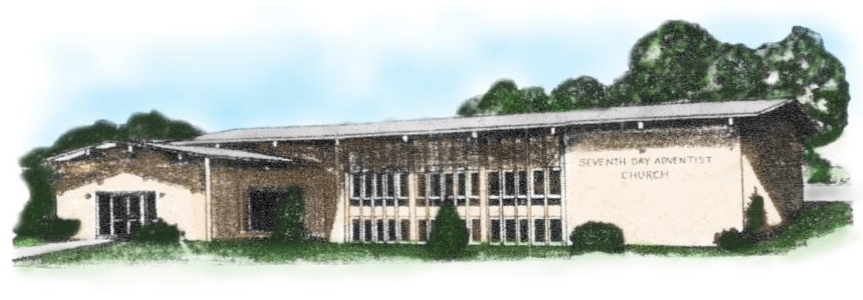

2117 LaCrosse St LaCrosse,Wi 54601

