 | Calendar
July 12 | Pickleball - Sunday | 4:00p
July 14 | Community Services Tuesday | 1:30-4:30p
July 14 | Pickleball -Tuesday | 6:30p
July 15 | Prayer Meeting | 6:00p
July 16 | Pickleball – Thursday | 6:30p
July 16 | Community Services Thursday | 9a-1p


Birthdays – July 13 Hadassah Eckright
July 13 CJ Taylor

Church Budget
Monthly Budget | $10,720.00
Month to Date 07/04/26 | $432.20
Under Year-To-Date | $16,843.44
Remember Online Giving!

Other Financial Needs:
Jellico Christian Radio 96.5 FM $350/month.

“Who are You”
July 11, 2026
Next Sabbath
July 18, 2026
Speaker | Communion |  | San. Teacher | Regina E
Elder | Steve Boone |  | Room Teacher | Mark P
Offering | Church Budget |  | Potluck | Baked Potatoes /Haystacks

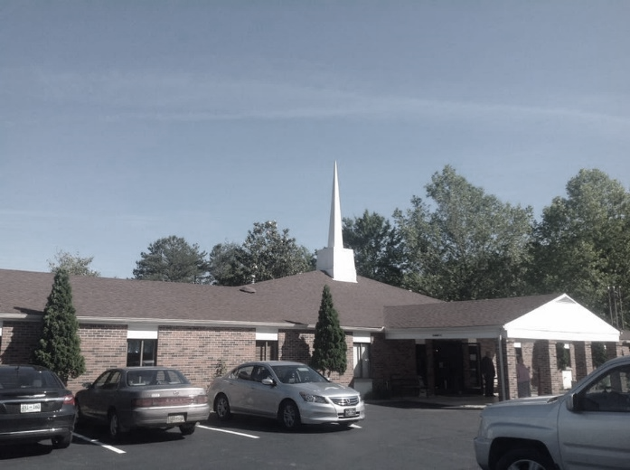
Jellico
Seventh-day Adventist
Church
Welcome to the Jellico Seventh-day Adventist Church. We hope you have a blessed Sabbath.
“Who are You”
July 11, 2026

Prelude |  | Heidi Gaitan
Invocation |  | Mark Powell
Opening Hymn | “I would be like Jesus” | #311
Call to Worship |  | #
Pastoral Prayer |  | Darryl Wilkens
Offering | “GCC Session Offering Missions” | Darryl Wilkens
Offertory |  | Heidi Gaitan
Doxology/Prayer |  | Darryl Wilkens
Children’s Story |  | Regina Escalante
Special Music |  | Sarah Neacsu
Scripture Reading | “Colossians 3:2-4” | Darryl Wilkens
Sermon | “Who are You” | Mark Powell
Closing Hymn | “Live Out Thy Life Within Me” | #316
Benediction |  | Mark Powell
Postlude |  | Heidi Gaitan
Please Pray for Be Thankful For
Each one of us here today will receive the Holy Spirit.  Riley Boone and family who are needing our prayers.  All those who have dealt with addictions. And those who have overcome it and begun a new and better life.  Mr. Dietmar, as he continues to make improvements in his home and prepare to bring his family there to live.  Those who came to the booth to fill out the card for the drawing for a Family Bible and asked for prayer request and or Bible studies. |  | “Give Thanks with A Grateful Heart” as each day goes by. 1Thess 5:18  All our visitors.  Beautiful weather both rain and sunshine.  Family members.  Jesus is coming again and very, very soon.  Blueberries are ready and the donations will go to JCA.
Sunset Today: 8:57pm Sunset Next Friday: 8:54pm

Bulletin Secretary is Cheryl McDaniel – Please text bulletin information to (423)494-1532 by Thursday evening.
Pastor Dwight Kruger—Phone - (317) 966-5892

Announcement
Potluck today is Asian.
The church website is http://Jellicotn.adventistchurch.org.
Wednesday nights Prayer Meeting at the church at 6pm we are doing Romans.
Happy Sabbath Everyone!

