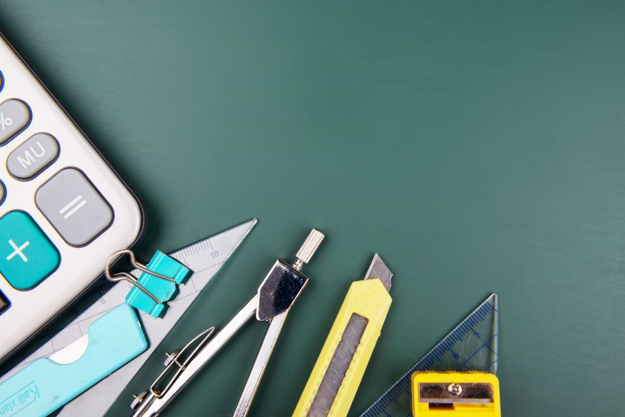

Ozark Adventist School
Grades 5/6 School Supply List
2026-2027

- Headphones or earbuds to use with Chromebook (not expensive)
- 1 water bottle that will not spill or break when dropped on the floor
- 1 package of Clorox wipes
- 1 package of paper plates
- 3 boxes of tissues
- 1 pack of 50 plastic forks
- 1 pack of 50 plastic spoons
- 1 small package of bandaids
- One set of 3 plastic drawers- no bigger than 8 1/2 inches by 7 1/4inches wide

Thank you SO much!

