Mission
To draw the people of Windsor and surrounding communities to a center of Holy influence where Biblical truth can be presented and to provide a Christ-centered message of love, embodying acceptance, and forgiveness in a dynamic traditional worship service.
SABBATH SUNDOWN 8:25 P.M.

Contact Us

* Pastor Andrew Abbott- (509) 520-0568
amartina898@gmail.com

*Tracy Schafer- (970) 313-3549, tschafer.wehsda@gmail.com. Contact with bulletin information.

Find us:
www.windsorsda.org
www.facebook.com/Windsorelmhavensdachurch
www.youtube.com/@WindsorElmHavenSDA
Windsor Elm Haven Seventh-Day Adventist Church
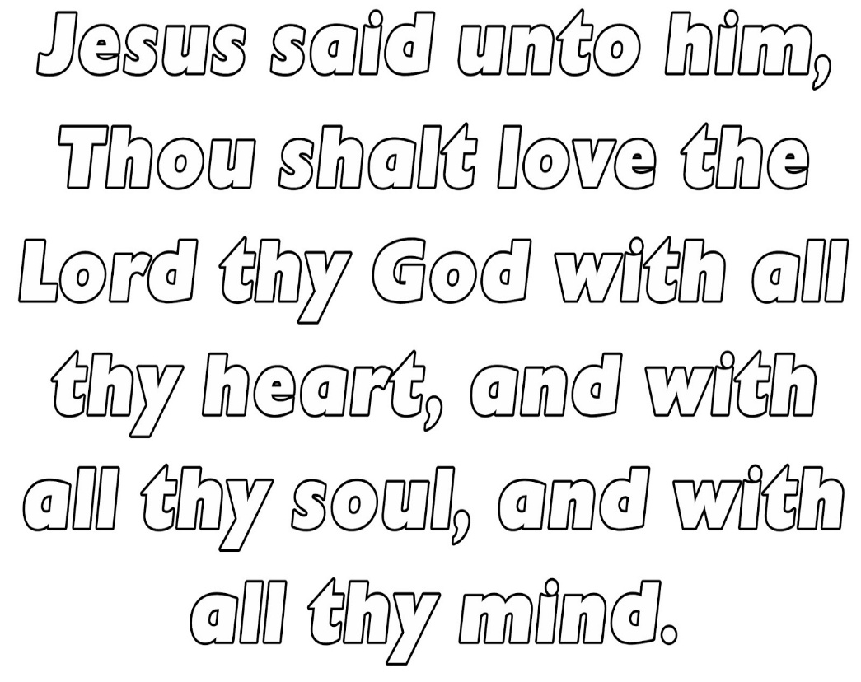

June 6, 2026 MATTHEW 22:37

33660 WCR 15 Windsor, Co
Sabbath School- 9:30 a.m.
Worship Service- 10:45 a.m.
Sabbath School
Song Service- #
Opening Hymn- #
Opening prayer & Sabbath School- Shawn Korgan

Worship Service
Song- #

Welcome and Happy Sabbath!!

Opening Hymn- #304 Faith of Our Fathers
Scripture Reading- Trish Escobar
*Joshua 4:21-24
Corporate Prayer-
*Steve Nothern, Mayor of Gilcrest
*Laura Fulton, Trustee Gilcrest
Offering and Prayer- Shawn Korgan
*Local Church Budget
(#190- Jesus Loves Me)
Story-
Special Music- Alax Bippes
Speaker- Pastor Abbott
“Altars and Teaching Tools ”
Closing Hymn- #287 Softly and Tenderly
Closing Prayer

Prayer Corner

*REMEMBER THE SABBATH DAY

*Let’s all pray for Pastor Abbott and his family! May God bless them and keep them through their mission.

*Keep praying for Windsor Elm Haven SDA and ALL its members!

*Pray for your neighbors near and far.

*Remember the unspoken prayers!! Hear our humble cry.
God hears them ALL. *Psalm 4:1

THY WILL BE DONE.

Speaker next week- Ray Garcia
Offering next week- Women’s Ministries

