Church Calendar

Today Power House Prayer 8:45 am
Sabbath School 10:30 am
Worship Service 9:15 am & 11:30 am
Next Sabbath Power House Prayer 8:45 am
Sabbath School 10:30 am
Worship Service 9:15 am & 11:30 am

Sunset Today 7:54 pm Next Sabbath 7:44 pm

Church Clerk: Loralee Mendez loraleemendez@hotmail.com
224-358-0786

Church Treasurer: Nathan Crouch 573-819-9008
colsda.ap@gmail.com

Church Board Chairman: Pastor Hiram Rester 417-848-7650
HiramRester@gmail.com

Bulletin Coordinator: Stacy Colley 573-933-0146
mscolley@centurytel.net

Audio Visual colsdaav@gmail.com

College Park Christian Academy 573-445-6315
office@cpchristian.org
www.cpchristian.com

School Principal: Sandra Blackburn
principal@cpchristian.org

College Park Christian Preschool 573-445-3418
www.cpcprek.com
Preschool Director: Natasha Gray 402-202-1700

Pastoral Team:
To aid in ministering to our congregation, we have divided our congregation among our church elders by the last name of head of household (see below). Sometimes ladies might need to discuss an issue and prefer another woman to talk too. In that case you might reach out to Sonita. Aggrey serves our Rwanda group named Hope.
Lead Pastor: Dr. Hiram Rester 417-848-7650
Joseph Bieksza -------------------(A-C) 573-544-3792
Andrew Gray ---------------------(D-I) 402-570-5539
Joe Parmele------------------------(J-P) 402-499-3750
Yaw Adu-Gyamfi ----------------(Q-Z) 302-883-7460
Sonita Simelus -------------------(Women) 573-529-9031
Aggrey Wanyonyi------------------(Hope) 573-446-4112

Morning Devotion Line:
6:00 to 6:30 am call: 1-712-770-4874 access code 558690#

For Your Information: If you would like to view the Livestream of the service or see the bulletin online, please go to the church website: http://columbiasdachurch.com

College Park Seventh-day Adventist Church

1100 College Park Drive

Columbia, MO 65203

573-445-2712


College Park
Seventh-day Adventist Church

Our Mission: Serve Others, Share Christ
and Develop Disciples.

August 29, 2026

Church at Study
10:30 am

The Berean's Lower Level
Refresh Sanctuary
Cradle Roll Room – Birth through 3 years Lower Level
Primary Room – 4 through 7 years Lower Level
Junior Room– 8 years through 12 years Lower Level
Youth – 13 years and up Lower Level

Church at Worship
9:15 am & 11:30 am

Prelude Emilie Howard*
Emilie Howard

Worship in Music Praise Team*
Praise Team

Welcome Pastor Hiram Rester

Announcements, Prayer & Offering Joe Parmele
Today's Offering is for Local Church Budget.
All loose offering goes to local church expense.
Thanks for prayerfully considering what God would have you give.

Special Music Sonita Simelus*

Worship in Word Pastor Hiram Rester

Closing Prayer Pastor Hiram Rester

Praise Team Leader Emilie Howard/Bob Dye *
Simelus Family

Postlude Emilie Howard *
Emilie Howard

*First Service
Announcements

Welcome to the College Park Seventh-day Adventist Church. We are so glad you chose to worship with us this Sabbath.


Church Calendar: Keep up to date with church events by scanning the QR Code or going to https://columbiamo.adventistchurch.org/events.

Join our prophecy bible study series with Pastor Hiram Rester every Wednesday, 7.15pm on Zoom. To join, Text “Bible” to 573 297 5077

CHURCH AT THE PARK-Sept. 19, 10am-Noon with lunch following. Please bring picnic foods (cold salads, chips, sandwiches, etc.). Also bring your own chairs. The church (both services) will be closed on that day, so please plan to join us.

There will be an inspiring men’s brunch on August 30th. Come and join other guys from the church in eating what we make. Stay for the inspiring speaker Mike Lowe. Additional information to come.

CPCA Preschool: Is looking for a new treasurer starting January 2027. Please contact Lloyd Hallock for more information.

International Sabbath is coming in October. There is a parade of flags. Contact Joe Parmele to make sure we have a flag from your country.

First Reading Membership Transfers:
- Calvin and Christine Dickhaut from College Park SDA Church to Fulton SDA Church.
- Peter and Pam Sutter from College Park SDA Church to Fulton SDA Church.
- Lauren Rester from College Park SDA Church to Corona SDA Church, Corona CA.
- Joseph Wischel from College Park SDA Church to Riverside Chapel SDA Church in Nashville TN.
- Melissa Taylor from College Park SDA Church to Pittsboro SDA Church in Pittsboro NC.

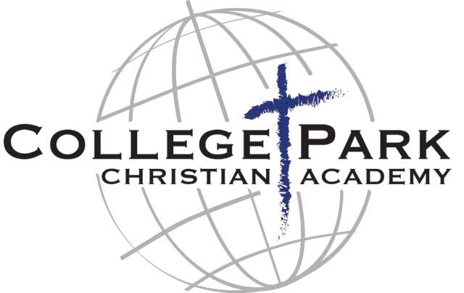

College Park Christian Academy is off to a great start! School began on Aug. 13. Our theme this year is “God’s Word Lights the Way” and our scripture verse is Psalm 119:105. We are excited to see how God will lead us this year.

Sabbath, Aug. 29

Worship Leader Joe Parmele

Greeters Robert Plank, Maryangela Wanyoni

Deacon Mike Maurizi*

Marc Bales
Sabbath, Sept. 5

Worship Leader ???

Deacon Matt Colley*

Mike Maurizi

Church Giving
Monthly Local Church Budget for 2026 $19,725.00
Received Current Month $19,733.37
Needed Year-to-Date $138,075.00
Received Year-Date $126,596.91
Ahead / Behind (-) YTD -11,478.09

Conference Evangelism Annual Goal $10,000.00
Received Current Month $267.00
Received Year-to-Date $5,643.00

Conference Refugee Ministry Goals $5,000.00
Received Current Month $513.00
Received Year-to-Date $3,985.00

Local Media Ministry Monthly Goal $750.00
Received Current Month $206.00
Needed Year-to-Date $5,250.00
Received Year-to-Date $3,371.04

Building Remodeling Loan Balance $102,797.19

Prayer Ministry

“Every Member a Praying Member”

“This week let's ask for the Holy Spirit to move before the church to prepare for the Fall Evangelism series.”

- Father, we ask that the Word of God come forth accurately and with love and grace during the meetings.
- Father, we ask that you anoint Pastor Hiram to preach with simplicity, boldness and accuracy.
- Father, we pray that those who hear the messages will not be able to resist the wisdom and beauty of the Gospel.
- Father, we entrust the details of this meeting, the people who will attend, and its protection to Your care.
- Father, we ask that you meet the needs of the people preparing the meetings and those attending so that their physical, mental, spiritual and financial needs will be met.

"And now I entrust you to God and the message of his grace that is able to build you up and give you an inheritance with all those he has set apart for himself." Acts 20:32 NLT

