2026-2027
Buena Vista SDA School
Code of Conduct
“Distinctly Academic; Decidedly Christian!

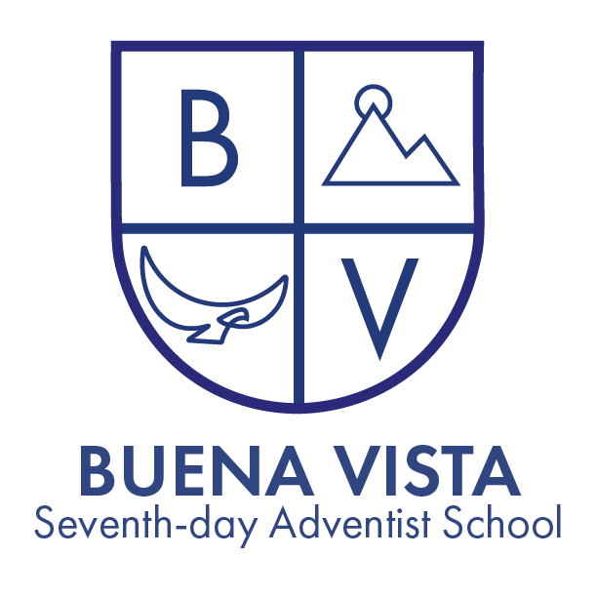
Buena Vista SDA School Code of Conduct
Purpose
This Code of Conduct exists to promote a safe, respectful, and Christ-centered learning environment. Students are expected to grow academically, socially, and spiritually by demonstrating integrity, kindness, responsibility, and self-control. Our standards are guided by biblical principles such as love, respect, honesty, and accountability.

Core Expectations
Students are expected to:
- Treat others with kindness, respect, and compassion.
- Follow directions from teachers and staff promptly.
- Demonstrate honesty and take responsibility for their actions.
- Use school property and resources responsibly.
- Strive to reflect Christ-like behavior in words and actions.

Restorative Practices
Whenever possible, the school will use restorative practices to:
- Help students understand the impact of their behavior
- Encourage accountability and reconciliation
- Promote spiritual and personal growth

Parental Involvement
Parents/guardians will be notified of significant behavioral concerns and are expected to partner with the school to support student growth and accountability.

Final Note
Discipline is administered with the goal of restoration, not punishment. Each situation will be prayerfully considered, with grace and truth guiding all decisions.

Mission Statement

Buena Vista Seventh-day Adventist School exists to lead each of its children into a close and saving relationship with Jesus Christ. Through His grace we seek to prepare them mentally, physically, and spiritually for a place in His service. We treasure each child who enters here as a gift of God.

1. Respect and Kindness
Expectations: Students are expected to treat others with respect and kindness, reflecting the teachings of Jesus Christ. This includes being polite, using kind words, and showing compassion.
Consequences:
- First Offense: Verbal warning and discussion with teacher.
- Second Offense: Written reflection on respectful behavior, meeting with parents and teacher.
- Third Offense: Meeting with principal, possible suspension.

DEFINITION
Respect and Kindness
Respect means treating others the way you want to be treated. It's about valuing other people's feelings, ideas, and belongings.
- Examples of respect:
  - Listening to others without interrupting.
  - Using kind words.
  - Taking care of shared spaces and materials.
  - Respecting differences.
Kindness means being thoughtful and caring towards others. It's about helping others feel happy and safe.
- Examples of kindness:
  - Helping a friend in need.
  - Sharing toys or materials.
  - Saying nice things to others.
  - Including everyone in play.
Respect and kindness help us build strong friendships and a positive community.

2. Weapons and Dangerous Items
Student Expectation:
Students must not bring anything to school that could hurt someone or make others feel unsafe. If a student sees something dangerous, they should tell a teacher right away.
Examples:
- Knives, guns, or anything that looks like a real weapon
- Toy weapons or realistic replicas (even if they are not real)
- Sharp or heavy objects used in an unsafe way

Consequences:
- Immediate confiscation and removal from school setting
- Parent notification and conference
- Immediate suspension
- Possible involvement of law enforcement
- Likely expulsion depending on severity
Definition: Possession or use of any object intended to cause harm or threaten safety.
Examples:
- Knives, firearms, or replicas
- Items used to threaten or intimidate others
- Any object used as a weapon

3. Technology Use
Expectations: Students must use technology responsibly, adhering to the school's acceptable use policy. This includes using devices for educational purposes only, not accessing inappropriate content, and respecting others' privacy.
Consequences:
- First Offense: Loss of technology privileges for one week, parental notification.
- Second Offense: Loss of technology privileges for one month, meeting with parents and teacher.
- Third Offense: Permanent loss of technology privileges, meeting with principal, and possible suspension.
DEFINITION:
Appropriate Technology Use in Elementary School (Grades TK-8)
Appropriate technology use means using digital devices and online resources in a safe, responsible, and respectful way. It helps us learn and grow while being kind to others.
Key elements of appropriate technology use:
- Safety: Protecting personal information and avoiding harmful online content.
- Respect: Using kind and respectful language online, respecting others' property and privacy.
- Responsibility: Using technology for learning and positive purposes, following school rules and guidelines.
- Digital Citizenship: Being a good digital citizen by understanding the impact of online actions.
Examples of appropriate technology use:
- Learning: Using educational apps and websites to practice skills and explore new topics.
- Communication: Using email and messaging to collaborate with classmates and teachers.
- Creativity: Using digital tools to create art, music, and stories.
- Research: Finding information online for school projects.
Remember: Technology is a tool to help you learn and grow. Use it wisely and responsibly.
4. Bullying and Harassment
Expectations: Bullying, harassment, or any form of intimidation is not tolerated. This includes physical, verbal, emotional, or cyberbullying.
Consequences:
- First Offense: Immediate intervention, meeting with parents, and counseling.
- Second Offense: Suspension and mandatory counseling.
- Third Offense: Expulsion from school.
DEFINITION
repeated, aggressive behavior that involves an imbalance of power. It is intended to hurt, harm, or intimidate another person. Bullying can be physical, verbal, emotional, or social.

Key elements of bullying:
- Repetition: The behavior occurs repeatedly or has the potential to be repeated.
- Imbalance of power: There is an unequal relationship between the bully and the victim.
- Intent to harm: The behavior is deliberate and meant to cause harm or distress.

Bullying is different from typical childhood disagreements or social conflicts. It involves a pattern of behavior that causes ongoing distress and fear.

Examples of bullying behavior:
- Physical bullying: hitting, kicking, pinching, spitting, taking or damaging belongings
- Verbal bullying: teasing, name-calling, insults, threats
- Emotional bullying: spreading rumors, excluding others, social isolation, blackmail
- Cyberbullying: using electronic communication to bully (e.g., social media, text messages)

It's important to note that occasional disagreements or conflicts between children are a normal part of development. However, when behavior becomes repetitive, harmful, and involves an imbalance of power, it crosses the line into bullying.

5. Academic Integrity
Expectations: Students are expected to maintain honesty in all academic work, avoiding cheating, plagiarism, and dishonesty.
Consequences:
- First Offense: Zero on the assignment, parental notification.
- Second Offense: Zero on the assignment, meeting with parents, and possible suspension.
- Third Offense: Meeting with principal and possible expulsion.
DEFINTION
Academic Integrity in Elementary School (Grades TK-8)
Academic integrity means doing your own schoolwork honestly. It’s about being fair, truthful, and responsible in your learning. This includes:
- Completing your own work: Doing assignments and tests without getting help from others unless allowed by your teacher.
- Being honest on tests: Answering questions with your own knowledge without cheating.
- Giving credit: Saying thank you and giving credit when you use someone else’s ideas or words.
- Respecting others' work: Not copying or sharing answers with classmates during tests or assignments.
Academic integrity helps you learn and grow as a student. It builds trust between you, your classmates, and your teachers.

6. Dress Code
Expectations: Students should adhere to the school’s dress code, promoting modesty and respect.
Consequences:
- First Offense: Verbal warning and change of clothes if necessary.
- Second Offense: Parental notification and meeting.
- Third Offense: Suspension until compliance.

DEFINITION
Dress Code
Dress code outlines appropriate attire for students while at school. Students are expected to maintain a neat, clean, and modest appearance at all times. Clothing should not be disruptive to the learning environment or disrespectful to others.
Neat: Clothing should be tidy and in good condition.
- Hair should be clean and neatly styled.
- Shoes should be worn at all times.
Clean: Clothing should be free from stains, rips, or holes.
- Good hygiene is essential.
Modest: Clothing should be appropriate for a school setting.
- Clothing should cover undergarments.
- Clothing should not be excessively revealing or tight-fitting.
- Clothing with inappropriate messages or images is prohibited.
The school administration reserves the right to determine if clothing violates the dress code.

7. Substance Abuse
Expectations: The use, possession, or distribution of alcohol, tobacco, drugs, or any illegal substances is strictly prohibited.
Consequences:
- First Offense: Immediate suspension, mandatory meeting with parents, and referral to counseling.
- Second Offense: Expulsion from school.

DEFINITION
Substance Abuse
Substance abuse means using harmful drugs or alcohol in a way that hurts you or others. These substances can make you feel sick, confused, or sleepy. They can also make it hard to think clearly, learn, or stay safe.
Important things to remember:
- Listening to your body is important. If something makes you feel bad, don't do it.
- It's okay to say no. You don't have to try something just because others are.
If you see someone using drugs or alcohol, or if you feel unsafe, tell a trusted adult like a parent, teacher, or counselor.

8. Attendance and Punctuality
Expectations: Students are expected to attend school regularly and arrive on time.
We believe that being in school every day and on time is super important for learning and growing. When students are present and punctual, they get to experience all the fun and exciting things happening in the classroom. It also helps them build strong friendships and become successful learners. Let’s work together to make sure we’re here, ready to learn, every day!

Consequences:
Consequences for excessive attendance/punctuality issues (missing or late more than 10% of the time in a given month) will result in:
1. Parent notification
2. Parent/school meeting
3. review by the admissions committee which may result in dismissal

Attendance and Punctuality
Attendance
Attendance means being present in school every day. Coming to school regularly helps students learn and grow. It is important to be in class to participate in lessons, activities, and to learn from the teacher.
Punctuality
Punctuality means arriving at school on time. Being on time helps students start the day prepared and ready to learn. It also shows respect for the teacher and classmates.
Regular attendance and punctuality are essential for academic success.

We understand that things change, and we want to make sure our school is always a safe and positive place for everyone. Sometimes, we may need to create new rules or guidelines to help us achieve this. When this happens, we will let parents know right away. These new rules will be just as important as the ones already in this handbook.

